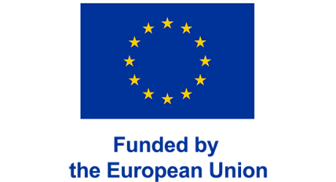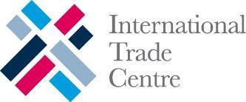

The Gambia Creative Industries & Tourism:
Regional Benchmarking & Market Positioning

Draft Date: Wednesday, October 29, 2025
1. Introduction and Methodology 5
1.1 Analytical Framework 6
1.2 Analytical Objectives 7
1.3 Data Sources 7
1.4 Sentiment and Persona Analysis 7
1.5 Methodological Continuity 8
2. Regional Creative Industries Digital Presence Comparative Analysis 8
2.1 Stakeholder Selection Methodology 8
2.2 Sector Digital Marketing Strategies 9
3. International Tour Operator Digital Representation Analysis 20
3.1 Methodology and Scope 20
3.2 The Gambia Creative Tourism Visibility & Positioning 21
3.3 Packaging Patterns 22
3.4 Narrative Positioning and Thematic Emphasis 22
3.5 Comparative Gaps 22
3.6 Strategic Implications for The Gambia 24
3.7 Creative Differentiation by Package Type 25
4. Visitor Perception of Gambian Creative Industries and Tourism Experiences 27
4.1 Methodology 27
4.2 Overall Sentiment Landscape 30
4.3 Sector-Specific Insights 30
4.4 Regional Thematic Benchmarking 31
4.5 Traveler Segment Insights 34
4.6 Strategic Implications 34
5. Creative Tourism Personas and Market Implications 35
5.1 The Five Evidence-Based Personas 35
5.2 Persona Insights 36
5.3 Cross-Persona Theme Signals 46
5.4 Strategic Implications 46
6. Digital Positioning Opportunities Matrix 46
6.1 Competitive Strengths and Gaps 47
6.2 Priority Opportunities Matrix 49
6.3 Implementation Roadmap and Metrics 50
6.4 Integration with Deliverable 3 54
7. Conclusion & Strategic Priorities 54
Annex 1 – Methodological Framework: Creative Industries Visibility Score 58
Annex 2 – International Tour Operator Analysis Framework 60
Annex 3 – Sentiment & Theme Taxonomy 64

Acronyms
CI - Creative Industries
DPOM - Digital Positioning Opportunities Matrix
EU - European Union
GBC - Ghana Broadcasting Corporation
ITC - International Trade Centre
ITO - International Tour Operator
JA - Jeune Afrique
MCN - Musée des Civilisations Noires (Museum of Black Civilizations)
NLP - Natural Language Processing
OTA - Online Travel Agency
PDP - Product Detail Page
Q&A - Question and Answer
RCV - Rádio de Cabo Verde (Radio of Cape Verde)
RTC - Radiotelevisão Caboverdiana (Cape Verdean Radio and Television)
SEO - Search Engine Optimization
SRK - Selly Raby Kane (designer)
TCV - Televisão de Cabo Verde (Television of Cape Verde)
TI - Tourism Industry
UGC - User-Generated Content
UTM - Urchin Tracking Module (a code for tracking URL performance)
UX - User Experience
VADER - Valence Aware Dictionary and sEntiment Reasoner (a sentiment analysis tool)
VR - Virtual Reality
YEP - Youth Empowerment Project
Executive Summary
Digital competitiveness in tourism defines how destinations are discovered, evaluated, and booked. For countries like The Gambia, whose cultural and creative economy underpins its tourism appeal, a visible and coherent digital footprint has become essential. Building on the Creative Industries Digital Baseline Assessment, this Regional Benchmarking & Market Positioning Analysis situates The Gambia within a wider West African landscape and against the perceptions of international tour operators.
It asks a simple question with complex implications: How does Gambian creativity appear to the world online, and what would it take to stand out?
This report extends the diagnostic work by comparing The Gambia's digital performance with five peer destinations—Senegal, Cape Verde, Ghana, Nigeria, and Benin—and analyzing how international tour operators frame West African cultural and creative tourism within their offerings. It introduces new layers of evidence: sentiment analysis drawn from more than 5,600 online reviews across six West African destinations, audience personas based on real digital-behavior data, and a positioning matrix that translates findings into investable opportunities.
Key Findings
1. Mid-Tier Digital Maturity with Structural Gaps
The Gambia ranks fourth of six destinations in regional creative-industry benchmarking. While individual actors demonstrate authentic storytelling (notably My Gambia and select festivals), the country trails Senegal and regional leaders Nigeria and Ghana in platform integration, search optimization, and content consistency. The Gambia also underperforms in Fashion & Design and Festivals.
2. Invisible in International Tour Operator Portfolios
Of 239 operator pages analyzed, only 9% highlight Gambian creative content (crafts, festivals, music), compared to 26% for Senegal and 21% for Ghana. The Gambia's average Creative Tourism Score is below the regional mean. Operators position the country almost exclusively through "beach + wildlife" narratives. Multi-country packages (Senegal + Gambia) score twice as high with respect to creative industries, suggesting The Gambia gains creative visibility when embedded in regional circuits.
3. Positive Sentiment Limited by Infrastructure Perception
The Gambia ranks first regionally in safety perception and is competitive in artistic quality and atmosphere. While Gambia performs above the regional average across all themes, Facilities & Infrastructure represents Gambia's lowest-scoring theme (relative to its own performance), making it a priority focus area for improvement. Visitor feedback identifies infrastructure concerns, including mentions of deteriorating heritage sites, poor signage, and limited interpretive materials appear across multiple reviews. The country is perceived as authentic but under-maintained—'liked but not looked for'—suggesting that infrastructure investment could enhance overall visitor satisfaction.
4. Five Distinct Personas Reveal Untapped Market Segments
Persona analysis identifies five statistically significant audience clusters:
- Market Explorers
- Heritage Seekers
- Learning Travelers
- Nature & Wildlife Connectors
- Dutch Immersive Explorers
These clusters, based on sentiment analysis of review data, could be used to more effectively target digital marketing efforts across all seven creative industry sectors.
The Core Challenge
The evidence reveals a paradox: The Gambia possesses authentic creative assets and generates positive visitor sentiment relative to the region, yet remains digitally invisible in the global cultural-tourism marketplace.
This gap is not structural but communicative. The country has stories to tell but lacks the platforms, language accessibility, and operator partnerships to tell them effectively. The Digital Positioning Opportunities Matrix presented in Section 6 identifies ten levers for addressing this gap, organized around three strategic priorities:
- ​​Rebalance the Narrative - Shift the country’s image from a “heritage + nature” destination to a creative-culture hub by curating consistent, multi-channel storytelling across crafts, music, design, and festivals.
- Close the Discoverability-to-Conversion Gap - Strengthen visibility where travelers actually search—TripAdvisor, Google Business, and tour-operator catalogues—and ensure every discovery pathway leads to a bookable or purchasable experience.
- Leverage Peer Learning and Strategic Aggregation - Build on regional success stories by pooling digital infrastructure, content libraries, and training programs, enabling small creative enterprises to achieve collective visibility and export readiness.
These priorities form the foundation for the forthcoming Strategic Digital Development Framework, which will translate diagnostic evidence into institutional roles, capacity-building programs, and sustainable monitoring mechanisms.

1. Introduction and Methodology
The creative industries of The Gambia are at the heart of the country’s cultural identity and its tourism brand. From fashion, design, and festivals to crafts, museums, and media, these industries represent both economic opportunity and national soft power. Their digital visibility, however, determines whether that creative vitality reaches the audiences who might visit, invest, or collaborate.
In 2025, the Creative Industries Digital Baseline Assessment established the first comprehensive picture of digital maturity across The Gambia’s cultural economy. It measured how visible creative stakeholders are online, how effectively they use platforms and content, and how far they have integrated digital tools into their operations. The results were revealing: while a small number of actors demonstrated professional online engagement, most of the sector remained digitally invisible.
From National Baseline to Regional Context
This report extends that foundation outward. It situates Gambian creative industries within a wider regional and market ecosystem, comparing their digital presence with that of peer destinations in Senegal, Cape Verde, Ghana, Nigeria, and Benin, and assessing how international tour operators portray West African creative and cultural experiences. The exercise shifts perspective from how ready we are to how we appear, placing The Gambia’s progress in relative rather than absolute terms.
By analysing the competitive positioning of neighboring destinations and international perceptions, this research explores questions central to tourism competitiveness:
- What digital strategies have allowed regional peers to reach their audiences more effectively?
- How is The Gambia currently represented in the international tourism marketplace?
- Which audience segments respond most strongly to creative experiences, and how can Gambian stakeholders reach them?

1.1 Analytical Framework
The regional benchmarking retains the external assessment component of Deliverable 1’s 100-point framework—the 70-point observable digital-presence audit—but omits the 30-point self-reported survey, which cannot be collected consistently across borders.
This ensures methodological continuity (same categories, scoring logic, and weighting) while keeping the exercise comparable and evidence-based.
Assessment dimensions:
- Social Media Business Presence
- Website Presence & Functionality
- Visual Content Quality
- Online Discoverability & Reputation
- Digital Sales / Booking Capability
- Platform Integration
Scores for Senegal, Cape Verde, Ghana, Benin, and Nigeria were derived from publicly available digital assets—websites, OTA listings, and social-media channels—assessed between September and October 2025. Each country’s sample of 35 stakeholders covers parallel sub-sectors (crafts and artisan products, fashion and design, cultural heritage sites, festivals and culture, audiovisual, performing and visual arts, marketing/advertising). This phase expands the scope from national assessment to regional comparison and international market perception. The result is a multidimensional analysis combining quantitative benchmarking, qualitative sentiment mapping, and digital-audience segmentation.

1.2 Analytical Objectives
Three complementary objectives guided the design of this assessment.
- To benchmark The Gambia’s creative-industry digital maturity against comparable West African destinations, thereby revealing competitive gaps and opportunities.
- To evaluate how international tour operators (ITOs) portray West African creative and cultural experiences online, identifying where The Gambia’s products appear and where they do not.
- To translate audience behavior into actionable insights through sentiment analysis and persona development, showing how prospective visitors perceive and engage with creative-tourism content in the region.
Together, these dimensions align with ITC’s mandate to transform diagnostic data into practical intelligence for export-competitiveness strategies.

1.3 Data Sources
The analysis drew from a combination of primary and secondary data:
- Creative-Industry Benchmarks – Comparative dataset of 175 stakeholders across five West African regional competitors (Senegal, Cape Verde, Ghana, Nigeria, Benin).
- International Tour-Operator Dataset – Review of 239 tour pages from 32 operators across 13 source markets (UK, France, Germany, Netherlands, Spain, USA, Canada, Italy, Belgium, Switzerland, Nordic markets, South Africa, and Nigeria).
- Sentiment Analysis – More than 5,600 individual reviews collected from TripAdvisor between 2021 and 2025, representing both Gambian and regional creative-tourism products across six West African countries.
- Supplementary Validation – ITC/YEP stakeholder consultations and the digital-assessment spreadsheet (provided by YEP team, October 2025) to confirm scoring consistency and weighting accuracy.

1.4 Sentiment and Persona Analysis
To complement quantitative scores, qualitative perception was captured through a VADER-based natural-language-processing model calibrated for tourism vocabulary. Each review or post was parsed for positive/negative polarity, yielding aggregate sentiment averages by country and theme (more on these themes can be found in Annex 3).
These behavioral data then informed five composite visitor personas, each defined by country of origin, travel motivation, digital behavior patterns, and expected online touchpoints. Personas were validated against engagement trends from the tour-operator and platform datasets.

1.5 Methodological Continuity
By maintaining the same scoring logic to Deliverable 1, the results in this report remain directly comparable to the national baseline. This continuity allows ITC and partners to monitor progress over time and to assess future improvements quantitatively when Deliverable 3’s strategic interventions are implemented.

2. Regional Creative Industries Digital Presence Comparative Analysis
This section benchmarks The Gambia’s creative industries against regional peers to understand how visibly and effectively they present themselves online. It compares more than 170 stakeholders across Senegal, Cape Verde, Ghana, Nigeria, and Benin.

The results highlight where The Gambia stands out for authenticity and storytelling strength, where visibility and integration lag behind regional leaders, and which near-market examples offer practical models for improvement.

2.1 Stakeholder Selection Methodology
Stakeholders in the Regional Assessment were selected to represent each of the above broad sectors across the target countries. Approximately five key stakeholders per category in each country, ensuring a balance across festivals/events, heritage sites, crafts markets, performing arts institutions, audiovisual media, fashion/design platforms, and media/publishing outlets.
This selection was guided by desk research and significance in the cultural landscape. For example, major cultural events with wide reach were included such as Nigeria’s Kano Durbar festival, a centuries-old celebration that attracts massive crowds (estimated in the hundreds of thousands during each parade).
Likewise, cornerstone national institutions and groups were chosen in the performing arts (e.g. Senegal’s Ballet National “La Linguère”, a state-founded troupe known for blending diverse ethnic dance traditions). In the crafts sector, the focus was on artisan hubs like Bonwire village in Ghana, famous nationally for its kente cloth weaving heritage. Prominent creative organizations in other domains were similarly picked – from leading fashion weeks (such as ARISE in Lagos, a prominent African fashion event) to influential media/publishing agencies.
By selecting well-known festivals, flagship cultural institutions, top artists/creators, and key industry events, the assessment captures a broad cross-section of the region’s cultural ecosystem. Each chosen stakeholder was validated for active presence in its sector (often via online search and local validation), with the aim of creating a list that reflects those most representative and impactful in their respective domains. This approach, grounded in both research and sector frameworks, aimed to cover “who’s who” in each cultural category, thereby faithfully representing the diversity of creative industry stakeholders in the region
Table 1 - Regional Creative Industries Overview – Digital Maturity Score
Country | Crafts | Audiovisual | Performing & Visual Arts | Marketing / Publishing | Fashion & Design | Cultural Heritage | Festivals & Events | Average /70 (%)
Ghana | 23.2 | 27.6 | 17.6 | 23.2 | 33.6 | 22 | 19.6 | 23.8
Nigeria | 27 | 29.2 | 32.6 | 27 | 26.8 | 21.2 | 15.2 | 25.6
Senegal | 18.8 | 14.2 | 19.2 | 22.4 | 29 | 26.8 | 13.6 | 20.6
Cape Verde | 19.4 | 25.8 | 7.2 | 26.4 | 16.6 | 19.4 | 19 | 19.1
The Gambia | 19 | 15.8 | 17.4 | 38 | 14 | 18.6 | 16.2 | 19.9
Benin | 15.8 | 12.6 | 18.4 | 18.2 | 17.2 | 22.8 | 24.4 | 18.5
Regional Mean | 20.5 | 20.7 | 18.7 | 25.9 | 22.9 | 21.8 | 18 | 21.2
Regional benchmarking confirms a clear stratification of digital maturity across West Africa’s creative industries. Nigeria leads, followed by Ghana and Senegal, while Cape Verde and Benin occupy mid-range positions defined by specialization rather than scale. The determining factor is not infrastructure but the degree of coordination between cultural production, digital communication, and, to a certain extent, tourism marketing.
One of Nigeria’s advantages lies in its integrated creator economy: film, music, and fashion actors apply platform-native practices, meaning they tend to design distinct content for each platform rather than simply reposting the same material across channels. On Instagram, for instance, fashion brands such as Adama Paris and Selly Raby Kane craft short, story-driven Reels and behind-the-scenes visuals. In the music sector, festivals like Felabration use YouTube’s livestream formats to extend performances online.
Senegal demonstrates high institutional capability but uneven diffusion: major festivals and museums achieve professional visibility, yet smaller enterprises remain sporadic online. Cape Verde performs best with a limited number of editorial platforms and sustains continuous international visibility for its music and cultural identity. Benin’s digital presence is concentrated in heritage institutions and national festivals, offering cultural depth but weak private-sector participation.
Across cases, three patterns emerge.
- First, consistency of content production—rather than funding level—correlates most strongly with visibility.
- Second, editorial coherence and language accessibility determine how well creative outputs connect to international audiences.
- Third, transaction capacity remains uniformly low, with few countries offering direct booking or payment systems for cultural experiences.
For The Gambia, these findings outline a path forward: emulate Nigeria’s content discipline, Ghana’s diaspora engagement, and Cape Verde’s editorial focus, while addressing the same structural weakness that constrains the entire region, the conversion of visibility into bookable, revenue-generating experiences.

2.2 Sector Digital Marketing Strategies
To start moving from data to action, it’s useful to see how leading creative-industry actors across West Africa are using digital tools to reach global audiences, and what The Gambia can learn from them.
Drawing on the top three performers in each sector, we highlight the practical strategies that drive visibility, engagement, and conversion, and how they could be applied to Gambian.creative industry participants

Each sub-sector summary includes:
- A short profile of three regional leaders (from Senegal, Cape Verde, Ghana, Nigeria, and Benin).
- A concise Insight Matrix comparing their digital practices with actionable steps for The Gambia.
- A short interpretation showing how these approaches can strengthen national competitiveness.
Together, these examples demonstrate that digital success in the creative industries depends less on scale and more on clarity, coordination, and consistency, qualities that The Gambia can adopt to amplify its creative identity and global reach.

Crafts and Artisan Products
Across West Africa, crafts remain one of the most direct and visible expressions of creativity. The region’s strongest digital performers—Global Mamas (Ghana), Nike Art Foundation (Nigeria), and Village des Arts de Dakar (Senegal)—show that visibility and authenticity are not opposites. Each uses a different model of digital excellence:
- Global Mamas blends fair-trade credibility with process-led storytelling, transforming artisanship into global e-commerce.
- Nike Art Foundation lifts up traditional arts through premium photography and integrated catalogues that reach collectors worldwide.
- Village des Arts de Dakar keeps accessibility central, using candid visuals and community-generated content rather than heavy web infrastructure.
Together they demonstrate that storytelling, usability, and coherence—not scale or funding—define digital maturity in the crafts sector.
Table 2 – Digital Marketing Insights for Crafts & Artisan Products
Dimension | What Regional Leaders Do | Application for The Gambia
Storytelling Approach | Lead with process and people: Global Mamas shows artisans dyeing and weaving; Village des Arts highlights daily studio life. | Shift from static product shots to narrative content—short “making-of” reels and artisan mini-profiles.
Website & Commerce Integration | Combine storytelling and e-commerce on one site; workshops and products co-exist. | Introduce a shared Gambian craft portal or integrate simple booking/payments (Stripe, WhatsApp Pay) for workshops.
Visual Identity & Quality | Use professional, consistent imagery; clear lighting, metadata, and cohesive color palettes (Nike Art Foundation). | Develop a national “craft photography guide” or content bank with downloadable templates.
Platform Integration | Link web, TripAdvisor, Google Maps, and fair-trade directories to reinforce trust and search visibility. | Claim and update Google Business profiles; cross-link to TripAdvisor Experiences pages and My Gambia listings.
Language & Access | Bilingual navigation (EN/FR) expands market reach and SEO visibility. | Translate key product and workshop pages into French and Dutch to reach two high-value origin markets.
Community Credibility | Highlight social impact metrics—income generated, artisans trained, sustainability practices. | Add simple “Impact Counters” or fair-trade icons to artisan bios to reinforce transparency.
Across leading examples, consistency and connection outperform complexity.
The most effective craft brands show the human process, maintain visual coherence across channels, and make it easy for global audiences to learn, trust, and purchase.
For The Gambia, even small coordinated steps—shared imagery standards, bilingual storytelling, and a lightweight e-commerce layer—would expand visibility and perceived value, transforming crafts from souvenirs into cultural showcases.

Fashion and Design
West Africa’s fashion scene demonstrates how digital storytelling can transform local creativity into global influence.
The region’s most effective digital leaders—Christie Brown (Ghana), Adama Paris (Senegal), and Selly Raby Kane (Senegal)—illustrate three complementary strengths:
- Christie Brown has mastered premium online merchandising, combining heritage-inspired textiles with editorial-grade visuals and smooth e-commerce.
- Adama Paris unites design with advocacy, using social media to link fashion and women’s empowerment across continents.
- Selly Raby Kane uses art-tech experimentation—VR, short films, and Afrofuturist imagery—to push African fashion into new creative territories.
Together they reveal that success in digital fashion depends less on runway scale and more on coherent brand identity, technological access, and narrative vision.
Table 3 – Digital Marketing Insights for Fashion & Design
Dimension | What Regional Leaders Do | Application for The Gambia
Brand Narrative | Each brand connects contemporary style to cultural roots: Christie Brown merges Ghanaian craftsmanship with modern silhouettes; Adama Paris champions African cosmopolitanism; SRK turns creativity into cultural commentary. | Encourage Gambian designers to work toward a single narrative voice—“what makes Gambian style distinct”—and embed it consistently across multiple channels.
Visual Identity | Professional, art-directed imagery across lookbooks, Instagram, and product pages; consistent lighting, palette, and typography. | Develop a shared visual-identity guide for Gambian designers; host collaborative shoots with consistent backdrops and tones.
E-Commerce & User Experience | Seamless product browsing, sizing charts, secure multi-currency checkout, bilingual UX. | Launch a collective digital boutique or Shopify-based hub offering unified checkout and international shipping.
Content Rhythm & Storytelling | Frequent storytelling—behind-the-scenes videos, collection launches, designer diaries—sustain engagement year-round. | Schedule monthly “collection stories” on social media; cross-share via a national creative calendar.
Cross-Sector Collaboration | Partnerships with art, music, and tech sectors extend reach (e.g., SRK’s VR exhibitions). | Pair Gambian designers with photographers, musicians, and digital artists to co-produce campaigns.
Market Access & Language | Bilingual content builds inclusivity and diaspora reach; Adama Paris uses both French & English audiences. | Offer dual-language fashion-site versions; highlight diaspora connections in storytelling.
West African fashion houses succeed by balancing authentic identity with digital sophistication.
For The Gambia, establishing a collective digital presence for designers—even through a single well-curated portal—would help to support national visibility, attract diaspora consumers, and signal readiness to participate in regional and global creative markets.

Cultural Heritage Sites and Museums
Cultural heritage institutions are redefining how history is preserved and shared online. The region’s standout examples—Fondation Zinsou Museum (Benin), Musée des Civilisations Noires (Senegal), and the National Museum of Ghana—show that strong digital engagement is achievable through coordination rather than scale.
- Fondation Zinsou Museum in Benin demonstrates how contemporary presentation can strengthen traditional content: clean layouts, professional imagery, and bilingual storytelling turn heritage into a living classroom.
- Musée des Civilisations Noires (MCN) in Senegal pairs education with commerce through online ticketing and product sales, proving that revenue generation and mission authenticity can coexist.
- The National Museum of Ghana integrates education, promotion, and innovation, uniting its website, social media, and tourism platforms under one cohesive digital ecosystem.
Together, these institutions reveal that digital strength in the heritage sector comes from integration, interpretation, and inclusion, not just the physical infrastructure.
Table 4 – Digital Marketing Insights for Cultural Heritage Sites & Museums
Dimension | What Regional Leaders Do | Application for The Gambia
Interpretive Storytelling | Zinsou and MCN use photography and curator notes to turn static exhibits into interactive narratives. | Introduce bilingual digital labels and short “story behind the object” videos or QR-linked curator quotes.
Integration of Culture & Commerce | MCN combines online ticketing, e-commerce, and donations within the same platform, linking culture with sustainability. | Enable online ticket purchase and a small “support preservation” donation feature for key sites (e.g., Kunta Kinteh Island, National Museum).
Visual & Educational Design | High-resolution images, clear infographics, and accessible typography make exhibits legible for all ages. | Refresh museum sites with mobile-friendly layouts, infographics on timelines, and downloadable education sheets.
Multi-Platform Accessibility | Content synchronized across websites, tourism portals, and Google Maps ensures every search returns credible info. | Audit and align all listings (TripAdvisor, Google, My Gambia) with identical details, hours, and photos.
Community Engagement | Zinsou curates local art workshops; MCN invites schools and diaspora networks into ongoing discussions. | Develop “Heritage in Progress” updates and invite local creators to contribute art inspired by heritage sites.
Language & Inclusivity | Bilingual storytelling and diaspora outreach expand relevance beyond domestic audiences. | Add French content to all major museum pages; feature diaspora narratives and oral-history excerpts online.

Digital leadership in heritage depends on how stories are told and shared, not on exhibition scale.

Regional leaders use technology to extend education and engage audiences year-round. For The Gambia, adopting the same principles would strengthen both visitor understanding and international perception.

A unified digital ecosystem linking the National Museum, Kunta Kinteh Island, and regional heritage centers could reposition The Gambia as a modern steward of African history and culture.

Festivals and Cultural Events
Festivals across West Africa are no longer one-week spectacles—they’ve become year-round digital brands. The region’s most dynamic examples—AfroFuture (Ghana), Vodun Days (Benin), and Felabration (Nigeria)—demonstrate how visual identity, storytelling rhythm, and online usability can turn live celebrations into enduring cultural movements.
- AfroFuture (formerly Afrochella) shows the power of professional branding: bold design and clear ticketing transform it into an international youth-culture icon.
- Vodun Days (Benin) blends heritage and modern communication, using strong imagery and accessible information to present spiritual traditions as living culture rather than exotic ritual.
- Felabration (Nigeria) maintains global recognition by merging archival Afrobeat heritage with contemporary energy across social and streaming platforms.
Together they highlight that digital excellence in the festival sector stems from clarity, continuity, and community, qualities that remain largely under-developed in The Gambia’s event ecosystem.
Table 5 – Digital Marketing Insights for Festivals & Cultural Events
Dimension | What Regional Leaders Do | Application for The Gambia
Brand Identity & Design | AfroFuture’s cohesive color palette, logo system, and typeface unify all visuals across web, print, and video. | Develop a national festival-brand toolkit (logo templates, fonts, color codes) usable by Janjanbureh Kankurang and others.
Storytelling & Editorial Tone | Vodun Days communicates respect and context—combining ceremony photos with cultural education. | Balance authenticity and accessibility: use short captions explaining meaning behind rituals or performances.
Website Functionality & Ticketing | AfroFuture and MCN include real-time ticket purchase, artist line-ups, and travel guidance. | Create lightweight responsive websites for major Gambian festivals with online ticketing and visitor FAQs.
Social Media Rhythm | Felabration maintains year-round presence—artist teasers, historical clips, and fan interactions. | Post regularly between editions: “Countdown” and “Behind the Scenes” content to sustain audience engagement.
Partnerships & Cross-Promotion | Collaborations with influencers, tourism boards, and streaming platforms expand reach. | Link festivals to Visit The Gambia channels, local operators, and diaspora networks; stream performances on YouTube Live.
Language & Inclusivity | Bilingual content and visual captions widen global accessibility. | Add subtitles or posts for diaspora markets; feature inclusive visuals representing gender and youth diversity.

Digital visibility can help determine whether a festival becomes a national event or a regional brand. West African leaders achieve momentum by professionalizing design, maintaining year-round storytelling, and using online tools to turn attendance into community.

For The Gambia, modest but coordinated actions—shared branding standards, multilingual web content, consistent posting schedules, and integrated ticketing—would elevate its flagship festivals from local celebrations to recognized pillars of West African creative tourism.

Audiovisual (film, photography, TV, videography)
West Africa’s audiovisual industries blend traditional broadcasting, emerging film ecosystems, and new digital storytelling models to reach domestic and diaspora audiences. Three regional leaders—Radiotelevisão Caboverdiana (RTC, Cape Verde), Ghana Broadcasting Corporation (GBC, Ghana), and the Africa International Film Festival (AFRIFF, Nigeria)—demonstrate how both institutional and independent actors are redefining visibility through innovation and cross-platform engagement.
- RTC (Cape Verde) shows how a national broadcaster can modernize legacy systems by uniting television and radio under a single digital hub, integrating livestreams, archives, and diaspora content.
- GBC (Ghana) exemplifies newsroom convergence and youth-oriented production, delivering real-time news, culture, and entertainment through a single editorial workflow optimized for web and mobile.
- AFRIFF (Nigeria) illustrates how festivals can serve as film-industry accelerators—using strong visuals, curated storytelling, and influencer marketing to position African cinema as both art and industry.
Together they highlight that leadership in audiovisual media depends on integration, storytelling agility, and community relevance.
Table 6 – Digital Marketing Insights for Audiovisual
Dimension | What Regional Leaders Do | Application for The Gambia
Platform Integration | RTC merges TV and radio in one web ecosystem with archives and live streaming. | Develop a unified Gambia Media Hub bringing together TV, community radio, and independent film updates under one portal.
Film & Creative Storytelling | AFRIFF’s digital presence blends film trailers, industry panels, and artist spotlights to create a year-round narrative. | Use Gambian film festivals and production houses to showcase “behind-the-scenes” stories and creative collaborations online.
Community Engagement | RTC and GBC stream community events, education programs, and cultural content. | Partner with regional broadcasters and schools to produce short docuseries on creative talent and cultural heritage.
Monetization & Sponsorship | AFRIFF attracts brand partnerships through high-quality visuals and professional event coverage. | Develop branded content packages or livestream sponsorships for major Gambian festivals and creative showcases.
Capacity Building | AFRIFF invests in digital storytelling training (AFRIFF Academy). | Launch annual Gambia Digital Storytelling Lab with YEP to mentor youth in videography, editing, and online distribution.

Regional broadcasters prove that modernization is less about hardware and more about strategy and consistency.

By consolidating broadcast and film activities, investing in youth-led storytelling, and engaging diaspora audiences through digital-first formats, they turn national media into cultural ambassadors.

For The Gambia, creating an integrated audiovisual platform—and linking broadcasters, filmmakers, and creative educators—would transform fragmented visibility into a coordinated national storytelling engine that amplifies all other creative industries.

Performing and visual arts
Performing arts institutions are transforming digital platforms into extensions of the stage itself—places where audiences discover, engage, and participate long before a live event.
Three regional leaders—MUSON Centre (Musical Society of Nigeria), National Theatre of Ghana, and National Theatre of Nigeria—illustrate how presentation and rhythm, not just production budgets, shape audience loyalty.
- MUSON Centre (Nigeria) demonstrates visual consistency, photography, and design that communicates prestige while maintaining community engagement through steady social posting.
- The National Theatre of Ghana succeeds by pairing strong visibility with educational programming, transforming its website into both cultural reference and event calendar.
- The National Theatre of Nigeria shows that cross-platform integration—linking website, social channels, and ticket portals—creates trust and repeat attendance.
Collectively, these examples show that coherence, continuity, and credibility define digital maturity in the performing arts sector—three qualities The Gambia can emulate with achievable investments in content coordination and guide training.
Table 7 – Digital Marketing Insights for Performing & Visual Arts
Dimension | What Regional Leaders Do | Application for The Gambia
Visual Consistency as Identity | MUSON maintains professional event photography, unified tone, and branded stage backdrops across all channels. | Establish simple visual standards for event posters and photography; train community arts centers in consistent framing and color use.
Program Visibility & Calendar Design | Ghana’s National Theatre features searchable event calendars, archives, and educational programs. | Create a shared national “Arts Calendar” portal linking concerts, theatre, and visual-arts events with booking info.
Cross-Platform Integration | Nigerian theatres link websites, social feeds, and ticketing through partner websites to create logical user journeys. | Connect Gambian theatre and dance companies’ Facebook pages to a single central website with ticket purchase or reservation links.
Community Engagement | MUSON and Ghana’s National Theatre highlight audience reactions and student showcases. | Feature local audience photos and quotes; launch “Behind the Scenes” mini-reels to humanize performers.
Information as Cultural Service | Nigerian and Ghanaian sites provide program notes, artist bios, and history pages. | Add short synopses and artist profiles to event listings; include context about performance traditions.
Revenue Diversification | Online sponsorships and digital ads supplement ticket sales. | Offer digital program sponsorships and livestream-ticket options for diaspora audiences.
Digital excellence in performing arts depends on presentation as much as artistic talent.
Regional leaders maintain a professional yet approachable tone that treats each performance as a recurring conversation with audiences.
For The Gambia, establishing a unified digital stage—a central calendar, shared branding assets, and modest livestream capacity—would turn sporadic visibility into continuous engagement.
These changes would also support cross-persona goals, attracting Learning Travelers seeking context, Heritage Seekers craving storytelling, and Nature Connectors looking for authentic cultural evenings within their itineraries.

Marketing/advertising/publishing
Digital media has become the connective tissue linking West African creative industries with audiences and investors. The region’s most successful outlets balance editorial integrity with modern design, social rhythm, and multiple revenue streams. Three leaders—BellaNaija (Nigeria), Modern Ghana (Ghana), and Jeune Afrique (Senegal)—demonstrate how creative storytelling and business acumen combine to sustain visibility and trust in a fast-evolving information economy.
- BellaNaija (Nigeria) represents Africa’s digital-native model: lifestyle journalism that blends culture, entrepreneurship, and entertainment across web, social, and YouTube platforms. Its tone is approachable but data-driven, with strong use of visuals and community storytelling.
- Modern Ghana shows the power of speed and scale—publishing hundreds of daily updates across news, business, and culture, maintaining top search visibility in the region.
- Jeune Afrique illustrates a premium transformation: editorial authority turned into subscription-based digital products that attract professional and diaspora audiences.
Together, these outlets show that authority, accessibility, and adaptability define success in the region’s digital media landscape.
Table 8 – Digital Marketing Insights for Marketing / Media / Publishing
Dimension | What Regional Leaders Do | Application for The Gambia
Editorial Voice & Brand Identity | BellaNaija uses a warm, inclusive tone blending lifestyle, entrepreneurship, and culture, reinforcing creative optimism. | Develop a “Creative Gambia” editorial voice combining tourism, design, and cultural entrepreneurship to humanize national storytelling.
User Experience & Visual Design | Jeune Afrique’s sleek UX and Modern Ghana’s image-led portals make reading intuitive and visually appealing. | Redesign national and sectoral media websites with photo-driven layouts, mobile-first performance, and clear content hierarchy.
Cross-Platform Integration | BellaNaija and Modern Ghana synchronize updates across web, social, newsletters, and YouTube. | Implement consistent cross-posting workflows; create short-form video explainers for each major campaign.
Community & Contributor Networks | BellaNaija’s contributor system sources stories from diverse creators; Modern Ghana’s forums encourage reader debate. | Enable open submissions for creative success stories; spotlight Gambian artists, designers, and community entrepreneurs.
Revenue & Partnerships | Jeune Afrique and BellaNaija monetize through sponsored content, events, and cross-sector campaigns. | Pilot sponsored content opportunities for local SMEs; launch co-branded creative newsletters with tourism and design partners.
Regional Reach & Diaspora Engagement | BellaNaija’s pan-African lens and Jeune Afrique’s multilingual content attract global diasporas. | Publish bilingual features and diaspora interviews to position Gambian creativity within a regional narrative.
The most successful digital publishers in West Africa treat media as both a platform and a partnership model—balancing journalism, brand storytelling, and business innovation.
For The Gambia, emulating BellaNaija’s cross-sector editorial tone and Jeune Afrique’s polished UX could support local outlets beyond information sharing toward influence building.
By linking cultural reporting, creative profiles, and regional partnerships under one cohesive digital brand, The Gambia can transform its fragmented media ecosystem into a trusted amplifier of its creative economy.

2.3 Cross-Sector Synthesis
Across each of the creative-industry domains—from crafts and fashion to film and media—three consistent success factors define regional digital leadership.
- First, coherence: top performers maintain a unified narrative and visual identity that carries across channels, allowing even small institutions to appear global.
- Second, connectivity: digital maturity grows when creative actors link ecosystems—designers with media outlets, broadcasters with festivals, and cultural institutions with e-commerce and education.
- Third, conversion: visibility becomes value only when platforms make it easy to book, buy, or engage, turning inspiration into participation.
For The Gambia, these lessons point to an opportunity: the country’s creative assets already generate strong sentiment for authenticity and artistic quality, but they need coordinated digital presentation and distribution to translate admiration into demand.
The following section explores how these same dynamics play out beyond national borders—examining how international tour operators currently portray The Gambia within their global marketing, and what that reveals about the country’s creative-tourism positioning in relation to its regional peers.

3. International Tour Operator Digital Representation Analysis

3.1 Methodology and Scope
To complement the regional benchmarking of domestic creative-industry capacity, this section assesses how international tour operators (ITOs) portray The Gambia’s cultural and creative offerings in their digital marketing. The analysis examines not what Gambian stakeholders publish, but how they are represented within the global distribution system that shapes international perception and demand.
32 tour operators were analyzed, covering Europe (21), North America (5), and Africa + regional specialists (6). These include mass-market operators (e.g., TUI Nordic, Neckermann), niche responsible-travel companies (e.g., Responsible Travel, Naturetrek), and multi-country regional operators featuring Senegal–Gambia itineraries. Collectively they represent the primary international gateways through which West African cultural tourism is promoted to global audiences. The process was to first find ITOs selling The Gambia, then to see how this same group packaged The Gambia in comparison with its regional competitors (Senegal, Benin, Ghana, Nigeria, Cape Verde).
Each operator’s web content was extracted and evaluated using the Creative Industries Visibility Score framework (see Annex 1). The scoring model quantifies the relative visibility of creative-industry domains—heritage, crafts, performing arts, festivals, audiovisual, fashion & design, and publishing—within tour descriptions, highlights, and itineraries. The model employs a 0–10 scale per sector, weighted by content prominence, term diversity, and depth of description. Weighted aggregation produces an overall creative-tourism score, allowing comparison of destinations across operators.
The content-analysis pipeline applied a combination of extraction (Google Cloud Natural Language API and custom NLP dictionary of 150 keywords). The analysis covered 239 individual web pages published in English, French, German, and Dutch between September and October 2025, with a distinction made between a destination page (a company’s overview of the country) and a tour page (a page with a specific itinerary for sale).
The resulting dataset enables three levels of interpretation:
- Destination visibility – how prominently The Gambia appears relative to regional peers (Senegal, Ghana, Benin, Cape Verde).
- Sectoral representation – which creative industries are most or least featured across operator portfolios.
- Narrative positioning – how international marketing language frames The Gambia (heritage, nature, community, beach, or creative experience).

3.2 The Gambia Creative Tourism Visibility & Positioning
Analysis of 239 tour pages from 32 international tour operators across 13 source markets reveals that The Gambia remains significantly under-represented in global cultural-tourism portfolios. While operators maintain positive sentiment toward the destination, Gambia’s creative and cultural products seldom appear as core selling points.
The average Creative Tourism Score for Gambia-related packages is 16.9 / 100, compared to a regional mean of 30.9, ranking The Gambia fifth of six West African destinations. In most catalogues, the country is still framed through a “beach + nature” narrative rather than a creative or heritage-led positioning. The data thus indicate a strong reliance on natural assets to attract visitors, with limited cultural differentiation.
Table 9 - Comparative Performance
Country | Average Creative Tourism Score (/100) | Top Represented Sectors | Primary Narrative Frame
Benin | 52 | Heritage, Crafts, Festivals | Heritage and ritual culture as identity tourism
Ghana | 40 | Heritage, Crafts, Fashion | Diaspora and cultural return journeys
Nigeria | 38 | Heritage, Crafts, Fashion | Contemporary culture and creative industries
Senegal | 29 | Heritage, Crafts, Music | Francophone heritage and festival tourism
The Gambia | 17 | Heritage, Crafts, Performing Arts | Beach / wildlife with limited cultural elements
Cape Verde | 10 | Heritage, Music, Crafts | Resort-based island culture experiences
These results demonstrate that destinations with structured cultural narratives (Benin, Ghana) achieve higher creative-tourism visibility, whereas smaller Anglophone markets (Gambia, Cape Verde) remain perceived as peripheral leisure destinations.
Narrative Positioning and Thematic Trends
Textual analysis of operator marketing language shows that “Beach/Resort” (95 percent of tours) and “Wildlife/Nature” (91 percent) dominate thematic framing, followed by “Cultural Heritage” (74 percent). Mentions of creative sub-sectors such as music, festivals, or fashion remain lower (< 30 percent).
Sentiment analysis registers a positive mean tone (+0.24)—an encouraging baseline for repositioning—but indicates that enthusiasm centers on hospitality and scenery, not creative content.
Operators with higher creative scores, such as Responsible Travel (Benin multi-country, 77.5 / 100) and Palace Travel (Ghana pure, 77.5 / 100), explicitly integrate artisan workshops, museum visits, and live-performance components, elements largely absent from pure Gambian itineraries.

3.3 Comparative Gaps
The largest competitive gaps for Gambia lie in:
- Heritage interpretation (+12 points vs. Senegal) – sites like Kunta Kinteh Island are referenced but lack narrative depth
- Craft integration (+23 points vs. Ghana) – markets appear as shopping stops rather than structured cultural encounters
- Festival representation (+35 points vs. Benin) – few operators promote calendar-based cultural events.
These disparities underscore the opportunity to embed creative content more deliberately into tourism packaging and operator communications.
Overall, The Gambia’s low creative-tourism visibility is less a reflection of limited assets than of limited narrative integration within the international distribution chain. Operators perceive the country as a nature-leisure complement, not a cultural destination in its own right.
To close the gap, Gambia’s strategy should prioritize curated storytelling partnerships with operators already active in the region, develop bookable creative-industry products (crafts, festivals, workshops), and provide ready-to-use bilingual marketing materials that translate community-based creativity into itineraries recognizable to global buyers.
Table 10 - Visibility of Creative Content from West African Competitors
Sector | Average Visibility Across All Destinations | Gambia Score (0–10) | Regional Leader
Heritage Sites & Museums | Strong | 4.4 | 🇳🇬 Nigeria (9.7)
Crafts & Artisan Products | Moderate | 2.9 | 🇳🇬 Nigeria (7.6)
Performing & Visual Arts | Weak | 1.4 | 🇬🇭 Ghana (6.3)
Festivals & Cultural Events | Weak | 0.4 | 🇧🇯 Benin (6.8)
Audiovisual (Film, Photography, Media) | Weak | 1.3 | 🇳🇬 Nigeria (8.9)
Fashion & Design | Weak | 1.2 | 🇬🇭 Ghana (4.5)
Publishing / Storytelling | Absent | 0.7 | 🇸🇳 Senegal (2.2)
International operators associate The Gambia almost exclusively with heritage and crafts, which together account for over 70 percent of all cultural references in tour descriptions. Mentions of music—though modest—signal growing recognition of the country’s musical identity, especially in multi-country Senegal–Gambia packages that highlight drumming workshops or local performances. However, these inclusions are typically generic (“listen to local music”) rather than structured experiences (concerts, lessons, or curated encounters).
Other creative sectors remain underdeveloped in international narratives. Performing and visual arts are mentioned sporadically, mostly as photographic subjects, while festivals, audiovisual, and fashion appear only in passing. This narrow framing reinforces a perception of The Gambia as a static heritage destination rather than a living creative ecosystem.

3.4 Strategic Implications for The Gambia
For The Gambia, sectoral imbalance represents both a weakness and an opportunity. The strong baseline in heritage provides credibility, but sustained growth requires expanding into music and performing arts, areas that can deliver experiential depth with minimal infrastructure investment. Integrating live music, artist encounters, or performance workshops into existing itineraries would diversify offerings and align Gambia’s cultural image with regional trends.
In short, international operators already recognize The Gambia’s historic heritage; the next step is to ensure they also recognize its living culture.
International packaging patterns reveal how The Gambia’s tourism identity is constructed in the global market.
This structure has significant implications: while single-country tours deliver the majority of total volume, multi-country tours achieve more than double the creative-tourism score, confirming that cultural depth increases when The Gambia is contextualized within a wider regional narrative.
Table 11 - Comparative Positioning of Package Types
Package Type | Share of Gambia Offerings | Average Creative Score (/100) | Typical Positioning Frame
Pure Gambia Tours | 67 % (21 tours) | 16.9 | Beach–wildlife focus with heritage as secondary interest.
Senegal + Gambia Tours | 27 tours | 33.9 | Balanced nature–culture itineraries centered on shared heritage and riverine ecosystems.
Broader Multi-Country Tours | 9 tours | 22.7 | Overland West Africa circuits; Gambia appears as a short cultural stop or rest point.
Multi-destination products therefore generate stronger cultural representation, but at the cost of reduced local capture: travelers encounter Gambian heritage within a regional storyline rather than as an independent cultural destination. This reinforces The Gambia’s role as a supporting node, valuable for diversification but rarely marketed as the principal attraction.

3.5 Creative Differentiation by Package Type
Across the 239 international tour pages analyzed, only a handful of products achieve Creative Tourism Scores above 70 / 100.
The ten itineraries shown below—led primarily by Responsible Travel (UK), Palace Travel (US), and Explore! (UK)—reveal how multi-sector storytelling, language accessibility, and participatory design drive global visibility.
While none of these tours occur solely in The Gambia, their structure provides a ready blueprint: they curate experiences, not just sites, working in craft workshops, festivals, and performances to cohesive narrative.
Table 12 - Top 10 Creative Tourism Tours
Rank | Operator | Tour (Link) | Primary Destination(s) | Creative Tourism Score /100 | Distinctive Creative Elements
1 | Palace Travel | Best of Ghana (12 Days) | Ghana | 77.5 | Workshops in Kumasi (kente weaving), Cape Coast heritage interpretation, live music evening, contemporary fashion segments
2 | Responsible Travel | Ghana–Togo–Benin Cultural Circuit | Ghana / Togo / Benin | 77.5 | Multi-country artisan markets, Vodun ritual festivals, local design workshops
3 | Palace Travel | Discover Senegal & Ghana | Ghana / Senegal | 77.5 | Diaspora heritage sites, Francophone festival participation, artisan co-ops
4 | Responsible Travel | Cultural History Holiday in Ghana | Ghana | 76.2 | Cape Coast Castle interpretation, community storytelling sessions, craft demonstrations
5 | Responsible Travel | West Africa Explorer Tour, Marrakech to Cotonou | Ghana / Benin / Guinea-Bissau | 75.0 | Cross-border craft villages, festival attendance, traditional music events
6 | Responsible Travel | Best of Ghana Holidays | Ghana | 75.0 | Batik and weaving workshops, designer studio visits, storytelling on symbolism
7 | Responsible Travel | West Africa Tour | Togo / Benin / Senegal | 75.0 | Music and dance performances, Vodun Days festival, regional markets
8 | Responsible Travel | West Africa Tour, Bissau to Cotonou | Benin | 72.5 | Festival-based immersion with craft production and ritual heritage
9 | Explore! | Best of Ghana | Ghana | 71.2 | Balanced heritage–craft programming, festival integration, community encounters
10 | Naturetrek | Tailormade Holidays in Ghana | Ghana | 71.2 | Nature–culture hybrid linking performing arts and audiovisual storytelling

High-scoring itineraries (70–78 points) tend to share three structural traits:
- They incorporate at least three creative-industry sub-sectors, typically heritage, crafts, and performing arts.
- They frame activities through story-driven participation (workshops, performances, dialogues with artists) rather than passive sightseeing.
- They maintain language and accessibility parity, broadening international reach.
In contrast, single-country Gambian products rarely exceed 20 points, typically emphasizing beaches, birdwatching, and river safaris with minimal cultural framing, reflecting limited integration of bookable creative experiences.
These findings validate the scoring framework and highlight how narrative depth, multilingual access, and experiential design directly raise digital visibility. Higher-scoring itineraries integrate heritage interpretation and community engagement, features largely absent from single-country packages.

4. Visitor Perception of Gambian Creative Industries and Tourism Experiences

4.1 Methodology
Understanding how travelers perceive The Gambia’s creative and cultural offerings requires more than measuring visibility, it requires reading sentiment. This section examines how visitors describe their experiences online, drawing from 5,682 TripAdvisor reviews covering 72 tourism and creative-industry stakeholders across The Gambia and five regional peers.
A natural-language-processing model was applied to analyze tone and extract nine key themes
Table 13 - Unified Theme Taxonomy (Applied to All Stakeholders)
# | Theme | Keywords Detected (Sample) | Description | Primary Focus
1 | Cultural & Heritage Value | culture, heritage, history, historical, traditional, authentic, colonial, slave trade | Historical significance, cultural authenticity, preservation quality | Creative sites, museums
2 | Service & Staff Quality | staff, guide, friendly, helpful, knowledgeable, professional, hospitality, welcoming | Quality of guides, staff friendliness, professionalism | Tour operators, all sites
3 | Facilities & Infrastructure | building, facility, clean, maintained, restoration, preserved, structure, condition | Physical infrastructure, maintenance, cleanliness | All stakeholder types
4 | Accessibility & Transport | access, location, transport, parking, ferry, signage, easy to find, difficult | Ease of reaching site, transportation logistics, wayfinding | Island sites, remote venues
5 | Value for Money | price, value, expensive, cheap, worth it, cost, fee, ticket, affordable, overpriced | Pricing perception, value received vs cost paid | All stakeholder types
6 | Safety & Security | safety, secure, comfortable, concerns, dangerous, protected, safe environment | Visitor safety perceptions, security presence | Nature reserves, urban sites
7 | Educational & Informational Value | learn, educational, informative, guide explanation, knowledge, interesting, fascinating | Learning opportunities, information quality, interpretation | Museums, heritage sites
8 | Artistic & Creative Quality | art, creative, talent, beautiful, craftsmanship, artisan, handmade, exhibition | Artistic expression, creative quality, craftsmanship | Craft markets, galleries
9 | Atmosphere & Overall Experience | atmosphere, experience, ambiance, feeling, vibe, stunning, wonderful, memorable | Overall visitor experience, emotional resonance | All stakeholder types
Scores were aggregated at stakeholder, sector, and country levels to benchmark The Gambia’s performance against Senegal, Ghana, Nigeria, Benin, and Cape Verde. Reviews span 2019–2025, ensuring comparability between pre- and post-pandemic visitor perceptions.
The perception study combined automated sentiment analysis with thematic text mining and manual validation:
- Sentiment Scoring Engine – Reviews were processed through the Valence Aware Dictionary and sEntiment Reasoner (VADER) model, an established natural-language-processing tool optimized for social and review text.
  - Scale: −1 (very negative) to +1 (very positive).
  - Accuracy: Manual coding of 200 samples confirmed ≈ 87 % alignment between machine and human scoring.
- Theme Extraction – Each review was scanned for a controlled vocabulary of 100 + keywords grouped into nine cross-sector themes. Context filters removed false positives, and a relevance score (0–1) was assigned according to keyword density and proximity.
- Data Quality Controls – Duplicate, spam, or purely promotional posts were removed. Non-English reviews were translated, while keeping the original language data to maintain source markets.
- Aggregation and Benchmarking – Theme scores were averaged by stakeholder, sector, and country, enabling comparison across six destinations.
Together these steps provide a replicable, data-driven map of how visitors emotionally evaluate Gambian creativity, from museum storytelling and market authenticity to service quality and safety.

Why TripAdvisor Was Chosen
Coverage across the main review platforms was verified using data from the Creative-Industries (CI) and Tourism-Industry (TI) assessments. Results show that TripAdvisor remains the only platform with both meaningful adoption and structured, comparable reviews, while Facebook and Google Business are too limited or inconsistent for analysis.
Table 14 - Stakeholder Activity on Platforms with Reviews
Platform | Creative-Industry Stakeholders (61 total) | Tour-Operator Stakeholders (21 total) | Comment
TripAdvisor | 15 listed (≈ 25 %) | 17 listed (≈ 81 %), 9 pages accepting reviews | Only platform with consistent review volume and structure suitable for sentiment analysis.
Google Business | 8 listed (≈ 13 %) | 2 listed (≈ 10 %) | Coverage too low for quantitative comparison.
Facebook Reviews | 23 pages enabled (≈ 38 %), but only 9 active (≈ 15 %) | – | Pages exist but few collect reviews; content largely unstructured.
Regional benchmarking confirmed a similar pattern across peer destinations: TripAdvisor coverage averaged roughly one-third of all assessed stakeholders, still far exceeding Google or Facebook review availability. This consistency enables credible cross-country sentiment analysis.
TripAdvisor was therefore selected as the primary data source because it:
- Provides the only structured and comparable body of international traveler reviews across Gambian and regional stakeholders
- Reflects the same international audience analyzed in the tour-operator visibility study (Section 3)
- Offers standardized star ratings and timestamps compatible with the VADER sentiment-analysis pipeline.
Other platforms remain useful for monitoring domestic engagement but currently lack the review depth and uniformity required for regional benchmarking.

Limitations and Mitigation
While the dataset provides a robust baseline, several caveats apply:
- Event coverage: festivals like the Janjanbureh Kankurang or Roots Festival seldom appear because TripAdvisor privileges static “places.” Future work should supplement with Instagram hashtag and Facebook-event sentiment, once stakeholders become more present and active on these platforms.
- Informal sector bias: small artisan workshops and street performers remain under-represented. Results therefore skew toward formal venues.
- Recency: post-COVID recovery years (2023–25) show improving tone but limited sample growth. Results will improve as travel continues to return to pre-pandemic levels.
Figure 1 shows the trajectory of TripAdvisor review volume for Gambian creative-industry stakeholders between 2019 and 2025. The steady post-COVID recovery provides context for interpreting sentiment patterns and signals where visibility is rebuilding most quickly.
Figure 1: Tripadvisor Reviews by Year for Gambian CI Stakeholders
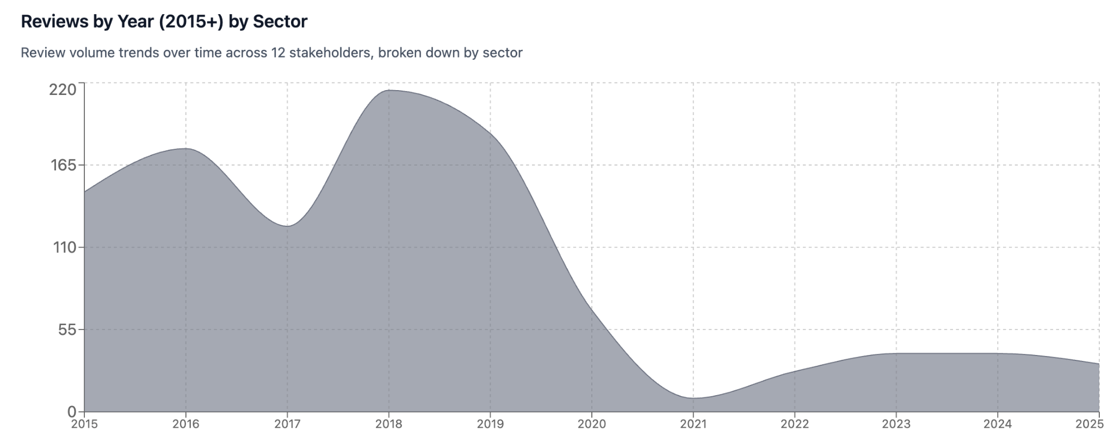
The upward trend highlights that creative and heritage-related venues are slowly regaining audience attention online (data was captured in September 2025), even as review coverage remains uneven across sectors. This growth in digital feedback strengthens the representativeness of the sentiment findings presented in later sections.
While TripAdvisor provides the most structured and comparable dataset for international traveler sentiment, it does not encompass every creative-industry stakeholder. Coverage is naturally skewed toward tourism-facing actors—sites, markets, museums, and operators that attract international visitors and therefore maintain TripAdvisor pages.
As a result, sectors with primarily local or informal audiences—such as community arts initiatives, design studios, or small-scale creative enterprises—are under-represented in the dataset. The analysis should therefore be understood as reflecting how The Gambia’s creative industries appear to international travelers, not as a census of all sector participants.
Despite these limitations, TripAdvisor offers the most comparable, statistically viable baseline for gauging how international audiences perceive The Gambia’s creative and cultural offerings. The results that follow (Sections 4.2–4.6) translate these numerical patterns into insight, highlighting what travelers praise, where frustrations cluster, and how sentiment diverges across sectors and source markets.

4.2 Overall Sentiment Landscape
Across all Gambian stakeholders, average sentiment stands at +0.24, equivalent to a 4.06 / 5 average rating, a solid mid-tier performance within the West African region.
- Tour Operators achieve stronger results (+0.28 sentiment; 4.23 / 5 rating) driven by service quality and guide expertise.
- Creative Sites (museums, markets, galleries) average +0.19 sentiment; 3.89 / 5 rating, reflecting high appreciation for artistry but frustration with infrastructure.
Regional comparison places The Gambia near the middle of the field: Ghana and Benin lead in heritage and education sentiment; Nigeria excels in creative vitality; Senegal shows balanced performance but benefits from stronger infrastructure investment.
Sentiment mapping across nine themes positions The Gambia as strong in experience and artistic quality, but weaker in infrastructure, accessibility, and educational value.
Figure 2 visualizes how The Gambia’s sentiment performance compares with regional leaders across nine visitor-experience themes. Each bar shows the difference between Gambia’s average score and the regional benchmark, as well as the regional leader in that theme, translating text analysis into an immediate visual snapshot of strengths and weaknesses,
Figure 2 - Gap Analysis: Gambia vs Regional Leaders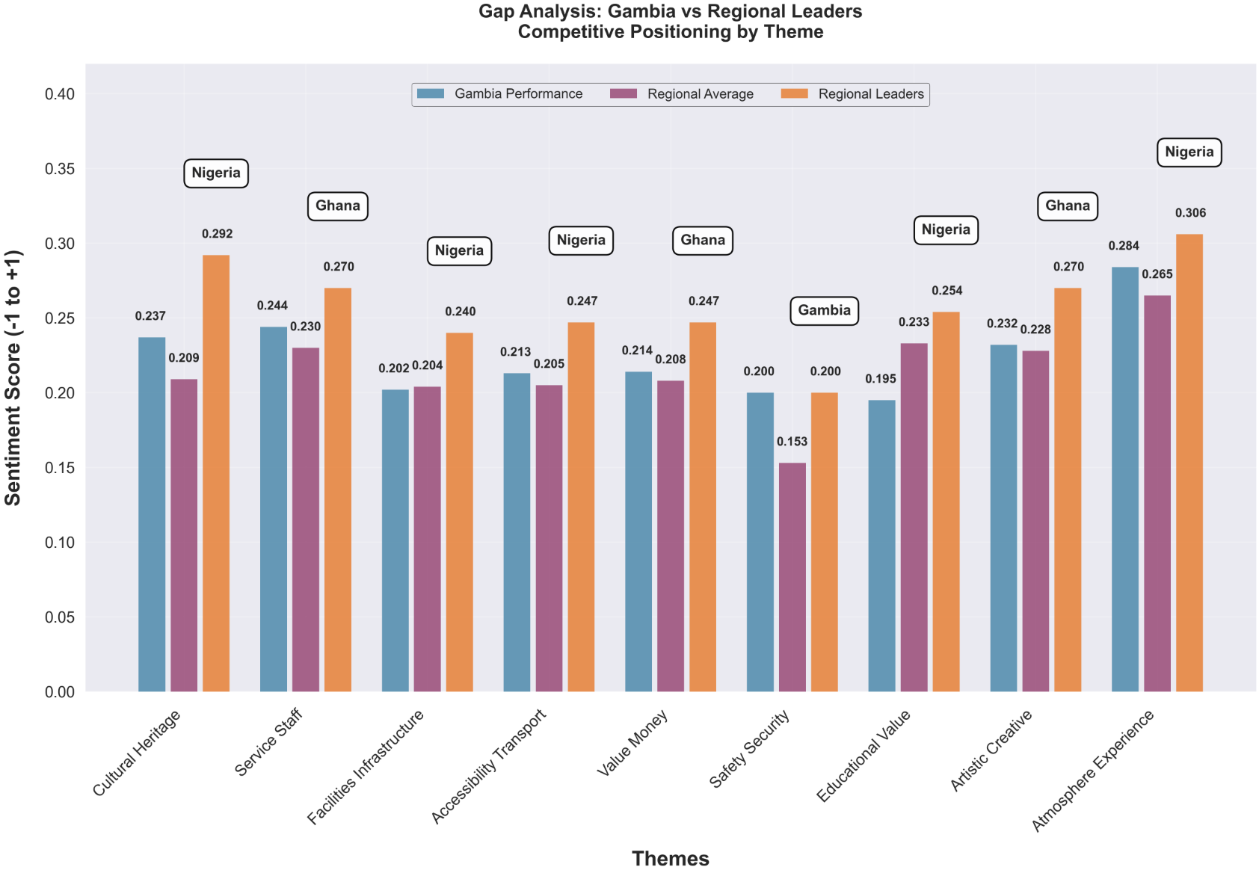
At first glance, the sentiment differences between The Gambia and regional leaders appear numerically small—often only a few hundredths of a point (for example, +0.24 versus +0.27).
However, in a dataset of over 5,600 reviews, such differences are both statistically and strategically significant. Each decimal point represents hundreds of individual traveler perceptions; consistently higher scores signal not just satisfaction, but credibility and readiness in the eyes of international audiences.
In tourism competitiveness, small perceptual margins compound over time, affecting review visibility, average-star ratings, and ultimately, how confidently tour operators feature a destination in their itineraries.
The Gap Analysis compares The Gambia’s average sentiment across nine visitor-experience themes with those of regional leaders—Ghana, Benin, Senegal, and Nigeria.
Each bar in the figure represents the difference between The Gambia’s mean sentiment score and the regional benchmark.
While the country performs above or on par in Safety & Security and Artistic & Creative Quality, shortfalls appear in Facilities & Infrastructure, Educational Value, and Accessibility & Transport. These are not marginal issues: together, they help explain the negative language detected in reviews and directly shape perceptions of credibility and readiness.
Why this matters:
- Infrastructure equals trust. Visitors equate physical upkeep and clear interpretation with institutional care. Even modest gaps in maintenance or signage reduce willingness to recommend destinations online, suppressing search visibility and tour-operator confidence.
- Interpretation drives meaning. Heritage and educational value are the core of creative tourism; when interpretive materials are missing or outdated, the emotional connection that underpins positive sentiment weakens.
- Accessibility affects shareability. Reviews mentioning “hard to find,” “poor transport,” or “no signs” correlate with a lower likelihood of a 5-star rating. Improving navigation, online directions, and ferry reliability would immediately raise both satisfaction and digital discoverability.
Strategic relevance:
- These thematic gaps align precisely with the personas that show friction in later sections: Max, the Heritage Seeker (interpretation deficit), Tom & Lena, the Nature Connectors (transport comfort), and Noah & Sarah, the Learning Travelers (educational structure).
- Addressing them converts intangible authenticity into measurable competitiveness.
- In the Digital Positioning Opportunities Matrix, these same gap areas evolve into actionable levers: Heritage Preservation Storyline, Guide Certification Program, and Comfort & Care Standards.
The gap analysis quantifies where visitor admiration turns into hesitation. Closing even small margins—particularly in infrastructure and interpretation—would move The Gambia from “authentic but under-maintained” to “authentic and reliable,” a shift with direct implications for both satisfaction scores and international operator marketing.

4.3 Sector-Specific Insights

Museums & Heritage Sites
Sentiment +0.16 | Rating 3.8 / 5 | 5 stakeholders, 427 reviews
Museums and heritage attractions generate strong emotional connection through authenticity and historical resonance—particularly around the trans-Atlantic slave-trade narrative—but consistently score low on infrastructure and interpretive depth. Visitors praise guides’ passion but note deteriorating facilities and limited signage.
Figure 3 compares theme-level sentiment for museums and heritage sites, revealing how visitors balance emotional engagement with practical experience factors.
Figure 3 - Museums & Heritage Sentiment Analysis Theme Comparison
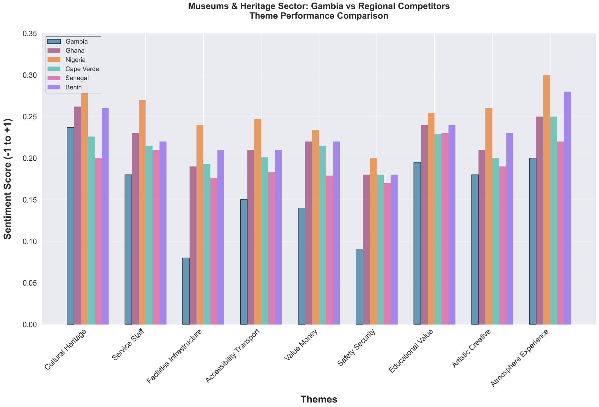
The chart confirms that authenticity and storytelling drive positive emotion, while infrastructure and maintenance issues suppress overall satisfaction. Enhancing interpretation and on-site comfort would yield disproportionate gains in review tone.
Heritage preservation and site maintenance are not simply physical concerns—they shape the credibility of national storytelling. Modest upgrades in ferry reliability, signage, and guide training could yield disproportionate sentiment gains.

Craft Markets & Artisan Spaces
Overall Sentiment +0.22 | Rating 4.1 / 5 | 4 stakeholders, 602 reviews
Visitors consistently praise Gambian craftsmanship and the authenticity of market interactions. The atmosphere is described as “vibrant” and “authentically African,” though some travelers perceive prices as high or negotiation pressure excessive.
Figure 4 visualizes how visitors evaluate Gambian craft experiences across the nine sentiment themes.
Figure 4 - Crafts & Artisan Products Sentiment Analysis Theme Comparison 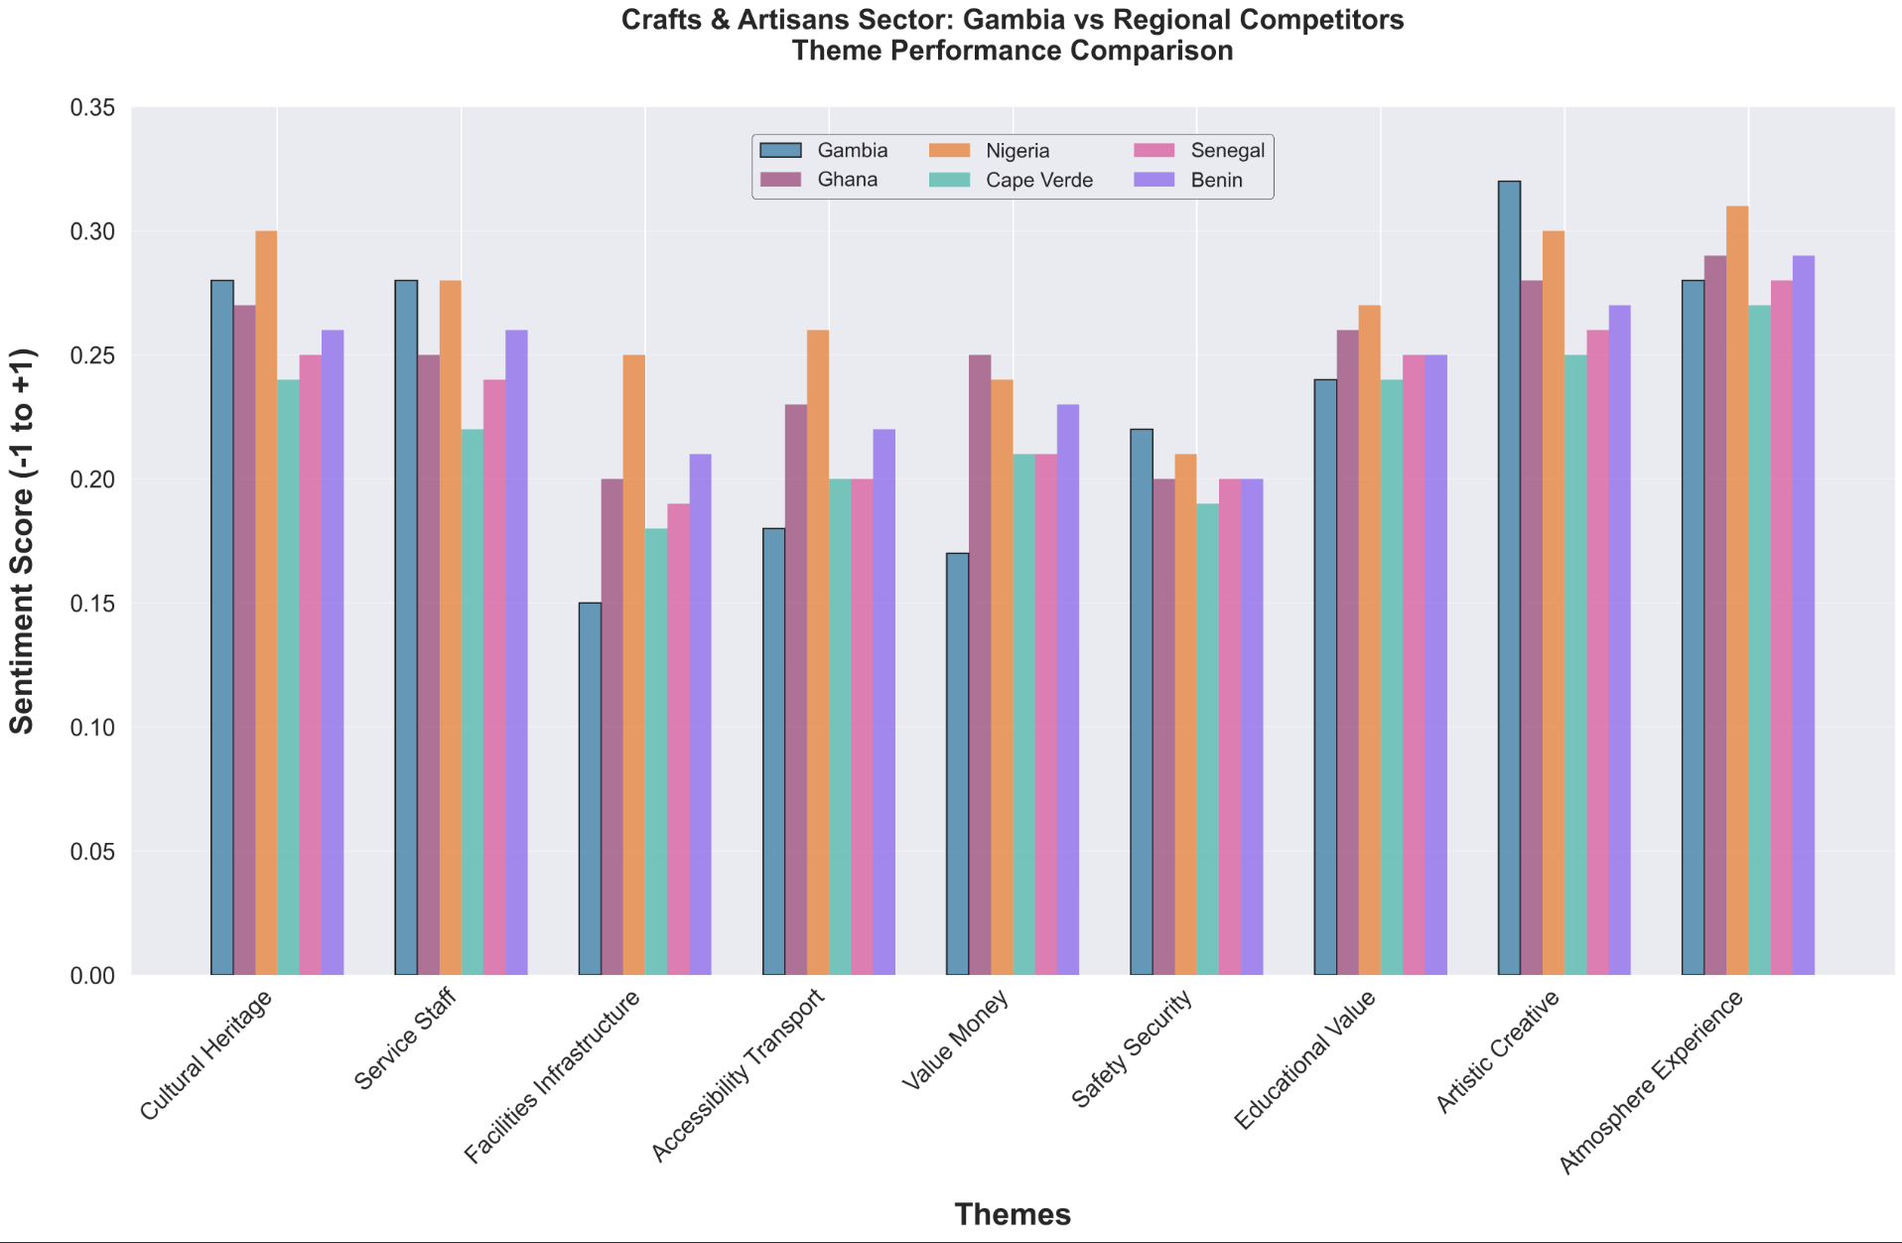Artistic quality and atmosphere rank highest, confirming the appeal of craftsmanship and human interaction. Lower scores in “value for money” suggest that transparent pricing and product storytelling could quickly elevate trust and spending. The opportunity lies in communicating value—linking pricing to artisan livelihoods and fair-trade production—to convert appreciation into perceived worth.

Tour Operators
Sentiment +0.32 | Rating 4.7 / 5 | 15 operators, 1,270 reviews
Tour operators are The Gambia’s best digital ambassadors. Reviews highlight exceptional guide professionalism and storytelling, with repeated praise for hospitality and organization. Negative feedback focuses on transport conditions rather than service delivery.
Figure 5 presents aggregated sentiment for Gambian ground operators, who function as the sector’s most digitally visible ambassadors.
Figure 5 - The Gambia Ground Operator Sentiment Analysis Theme Comparison 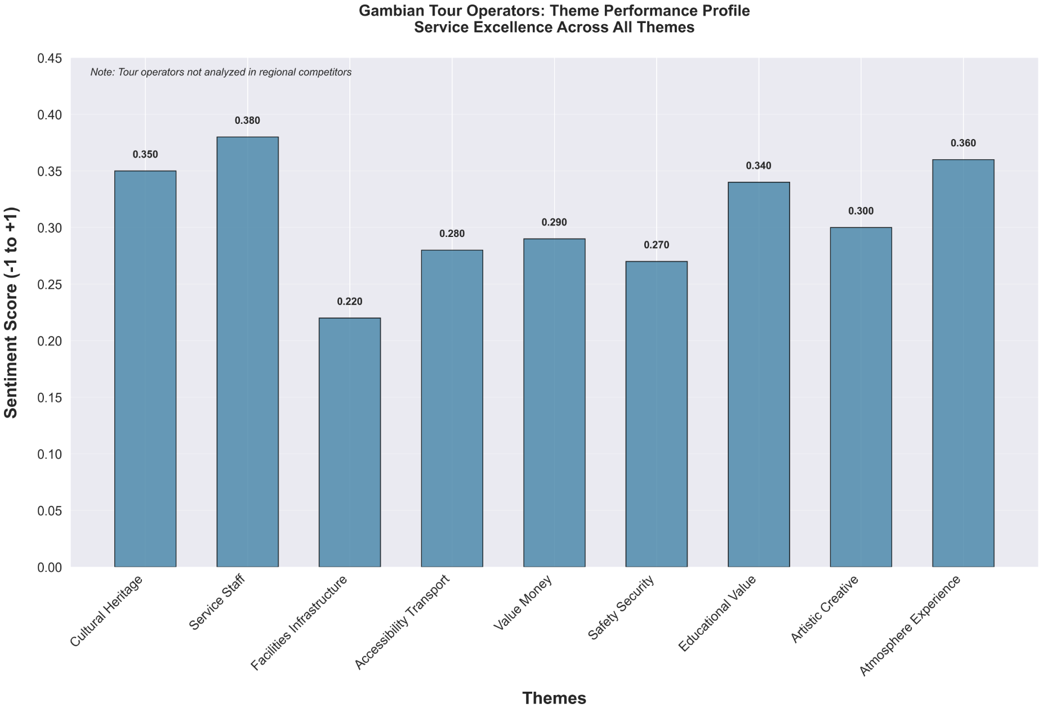
Service quality and staff professionalism score exceptionally high, underscoring the country’s comparative advantage in hospitality. Transport and facility concerns, however, continue to temper overall perception—areas where shared standards or certification could lift consistency across experiences.
Taken together, these visuals portray a coherent narrative: Gambian creative tourism earns praise for authenticity, artistry, and human warmth, yet loses momentum where physical comfort and interpretive depth fall short. The next section explores how these perception patterns vary by traveler origin and language market.

4.4 Traveler Segment Insights
Analysis of reviews with identifiable origin data and language reveals five consistent traveler clusters whose expectations differ markedly:
Origin Region | Share of Reviews | Avg Rating | Top Priority | Key Driver | Main Pain Point
UK & Anglophone Africa | 45 % | 4.32 | Educational value (31 %) | Knowledgeable guides | Infrastructure deficits
Netherlands / Belgium | 34 % | 4.56 | In-depth learning (38 %) | Expert guides, community benefit | Lack of interpretive detail
France / Francophone Africa | 15 % | 4.06 | Cultural heritage (21 %) | Authenticity, preservation | No French interpretation
Germany / Austria / Switzerland | 3 % | 4.15 | Organization (27 %) | Professionalism | Transport and facility issues
Spain / Italy / Portugal | 3 % | 4.01 | Artistic quality (25 %) | Visual appeal | Crowding and commercialization
The UK and Dutch markets dominate by volume and satisfaction, while the Francophone segment—though smaller—shows the greatest growth potential if language accessibility improves.

4.5 Strategic Implications
The preceding figures translate hundreds of visitor impressions into measurable insights. They show where The Gambia’s authenticity and service culture already compete regionally—and where infrastructure, signage, and interpretation gaps consistently erode otherwise positive sentiment. Building on these visual findings, five strategic priorities emerge to transform perception gains into market advantage.
- Transform Infrastructure into Experience. Reframing infrastructure improvements as part of cultural preservation (“heritage in progress”) can turn a weakness into an authenticity narrative.
- Transfer Service Excellence. Build a cross-sector guide and hospitality certification linking tour-operator standards to museums, crafts, and festivals.
- Localize for Language Markets. Introduce French and Dutch content across official channels to reach 49 % of reviewers in their own languages.
- Highlight Safety as a Differentiator. Leverage The Gambia’s top regional ranking in safety sentiment within brand messaging.
- Invest in Interpretation and Education. Develop interpretive signage and storytelling materials to meet the educational expectations of key segments.
Traveler sentiment confirms The Gambia’s core appeal—authenticity, friendliness, and artistic depth—but underscores a persistent “quality-of-experience” gap linked to physical and interpretive infrastructure.
Addressing these tangible barriers would not only raise review scores but also strengthen the country’s credibility as a creative-culture destination.

5. Creative Tourism Personas and Market Implications
To convert sentiment into market action, this section translates review data into practical audience segments, personas that reveal who current visitors are, what they value, and how they experience The Gambia’s creative industries. From these experiences, marketing actions can be taken to better target, engage with these visitors, and improve their stays.

Drawing from a base of verified TripAdvisor reviews and a refined subset of 982 reviews (exact count based on persona totals) with consistent thematic content, five personas were developed using a theme-based segmentation model. Each persona is statistically validated (n ≥ 100), offering both quantitative and qualitative insight.

In this analysis, a 'theme cluster' refers to a group of reviews sharing a dominant emotional or topical focus—such as heritage, markets, nature, or learning—identified through sentiment scoring.

Each cluster represents travelers with high positive sentiment toward specific experiences or motivations. For example, a cluster of reviews expressing enthusiasm about markets and crafts reflects a ‘Market Explorer’ persona. These clusters provide a structured way to interpret how audiences connect emotionally to different dimensions of Gambian creativity.

Language was another factor in segmentation. Four personas emerged from English-language theme clusters representing the primary market, while one distinct Dutch-speaking persona represents a secondary but high-value audience segment.

5.1 The Five Evidence-Based Personas
The five personas derived from this analysis represent statistically significant traveler types who together account for all major audience groups engaging with Gambian creative industries. Each persona is defined by key behavioral characteristics, satisfaction levels, and improvement opportunities. This overview table summarizes their relative market weight, satisfaction, and strategic focus.

Table 15 - Five Creative Industry Personas
Persona | Share of Total Reviews | Avg Rating | Core Motivation | Key Strengths / Frustrations | Strategic Focus
Market Explorers | 24.7 % (176 reviews) | 3.75 / 5 | Craft markets, artisan retail | Value the vibrancy and authenticity of Gambian markets but often note price confusion and layout issues | Reorganize markets into story-rich, fair-trade-oriented spaces; use signage + QR codes for transparency
Nature & Wildlife Connectors | 19.5 % (139 reviews) | 3.68 / 5 | Wildlife encounters, photography | Praise guides and biodiversity; cite transport comfort and rest-area upkeep as weak points | Upgrade vehicles and facilities; link eco-tours with creative components such as crafts or photo workshops
Heritage Seekers | 16.1 % (115 reviews) | 4.24 / 5 | Historical and emotional connection | Value authenticity and storytelling; limited interpretive materials | Invest in bilingual signage, guide training, and a “Heritage in Progress” narrative
Learning Travelers | 14.7 % (105 reviews) | 3.98 / 5 | Depth, explanation, family learning | Appreciate knowledgeable guides; want more structured learning | Develop a Creative Guide Certification and educational content for families/schools
Dutch Immersive Explorers | 38.5 % (447 reviews) | 4.12 / 5 | Community immersion, impact learning | Highly satisfied but limited Dutch-language information | Publish Dutch-language content; package multi-day workshops with visible community benefits

These personas are theme-verified, with at least 82% consistency between the dominant theme and review sentiment. They illustrate clear pathways for market segmentation and provide a solid foundation for audience-specific marketing and experience design.

5.2 Persona Insights
The following pages translate thousands of verified TripAdvisor reviews into five evidence-based visitor personas.

Each persona represents a statistically distinct cluster within the sentiment dataset, validated through the nine-theme taxonomy and cross-referenced against the tour-operator visibility analysis.

Together, they turn data into empathy: showing who visits, what they value, and where digital presentation can close the gap between curiosity and conversion.

Market Shopping Enthusiasts
This persona emerged from the strongest keyword density in the artistic & creative quality and value-for-money themes. Nearly 90% of reviews in this cluster mention markets, crafts, or artisans—yet sentiment on pricing and layout scored below the regional average. These travelers admire authenticity but encounter friction in communication and discoverability.

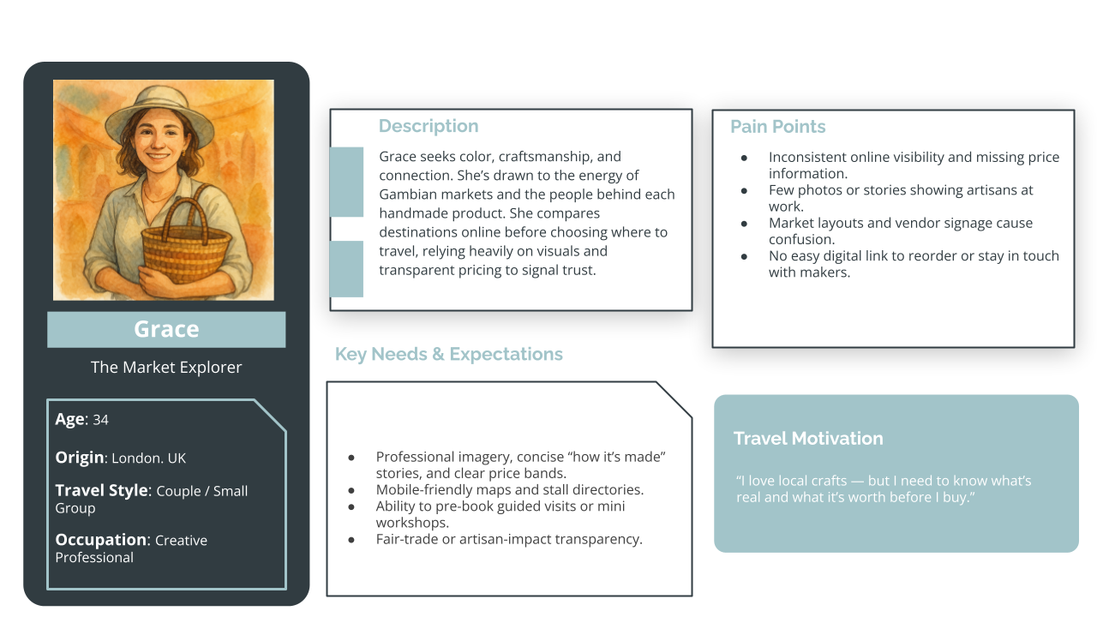
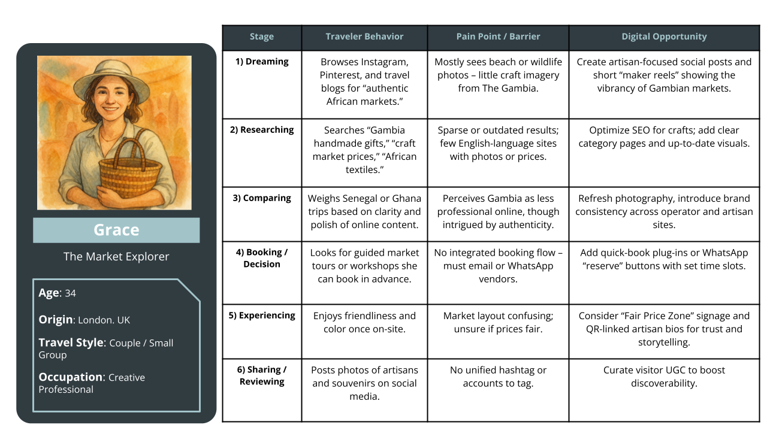
Key Evidence:
- 176 reviews (24.7%), Avg Rating 3.75/5
- Top themes: Market experience 89%, craft quality 76%, pricing value 67%, vendor interaction 54%

Strategic Implications: Reorganize markets into cultural showcases through better layout, posted prices, and artisan storytelling. Introduce QR codes for reorders and highlight fair-trade credentials.

Nature & Wildlife Enthusiasts
Identified through high co-occurrence of wildlife, guide knowledge, and educational value terms. Sentiment is positive but limited by infrastructure mentions in 45% of reviews. These travelers seek eco-tourism experiences enriched with cultural meaning.
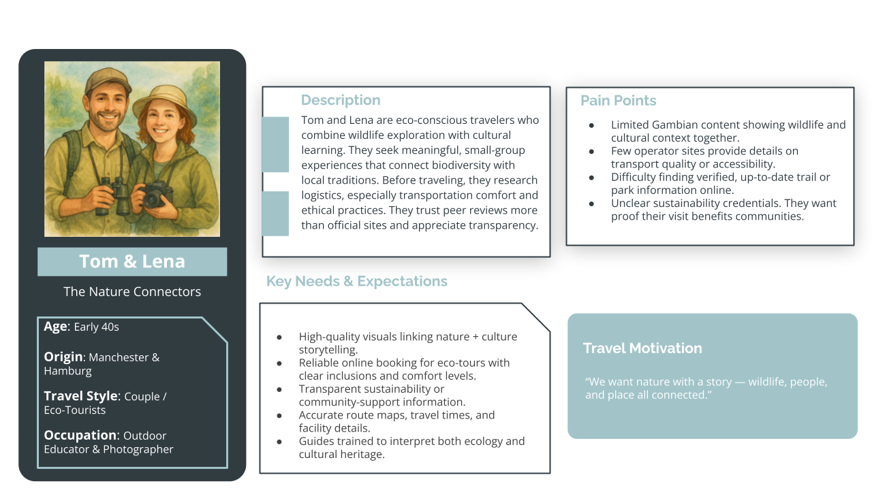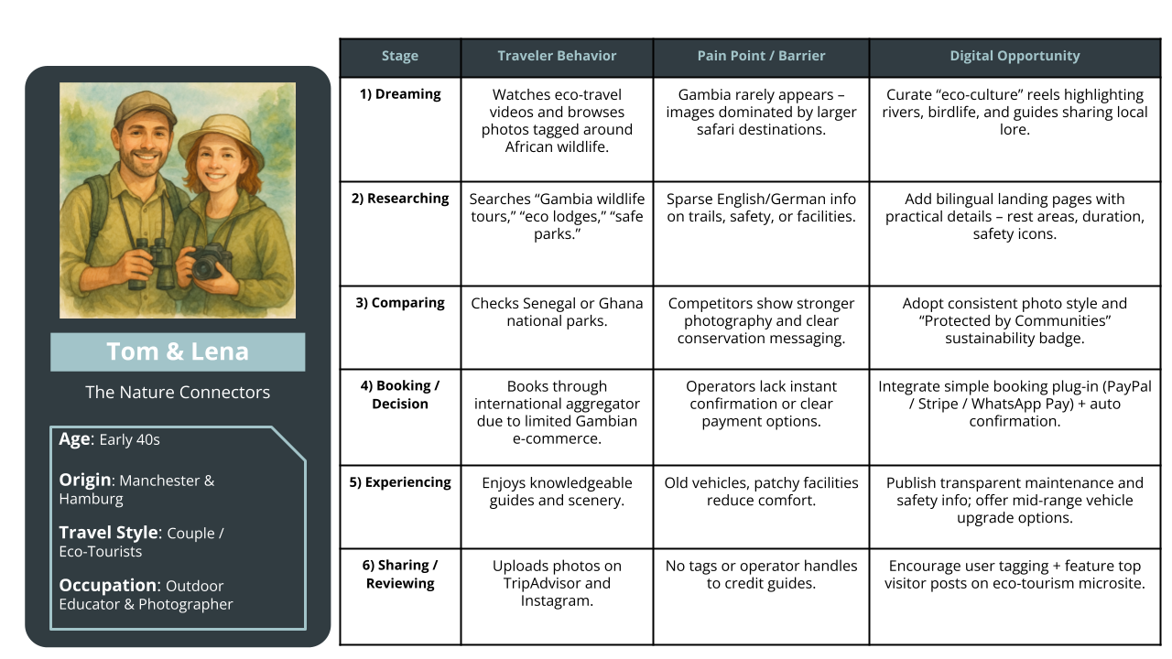

Key Evidence:
- 139 reviews (19.5%), Avg Rating 3.68/5
- Themes: Wildlife encounters 82%, guide knowledge 71%, natural beauty 68%, transport comfort 45%

Strategic Implications: Upgrade transportation and comfort standards. Combine eco-tours with cultural components such as eco-crafts or photography workshops to merge conservation with creativity.

Cultural Heritage Enthusiasts
Derived from the highest heritage value and educational content frequencies (> 80 %) across museum and historical-site reviews. Sentiment peaks at +0.27 but dips when referencing infrastructure.
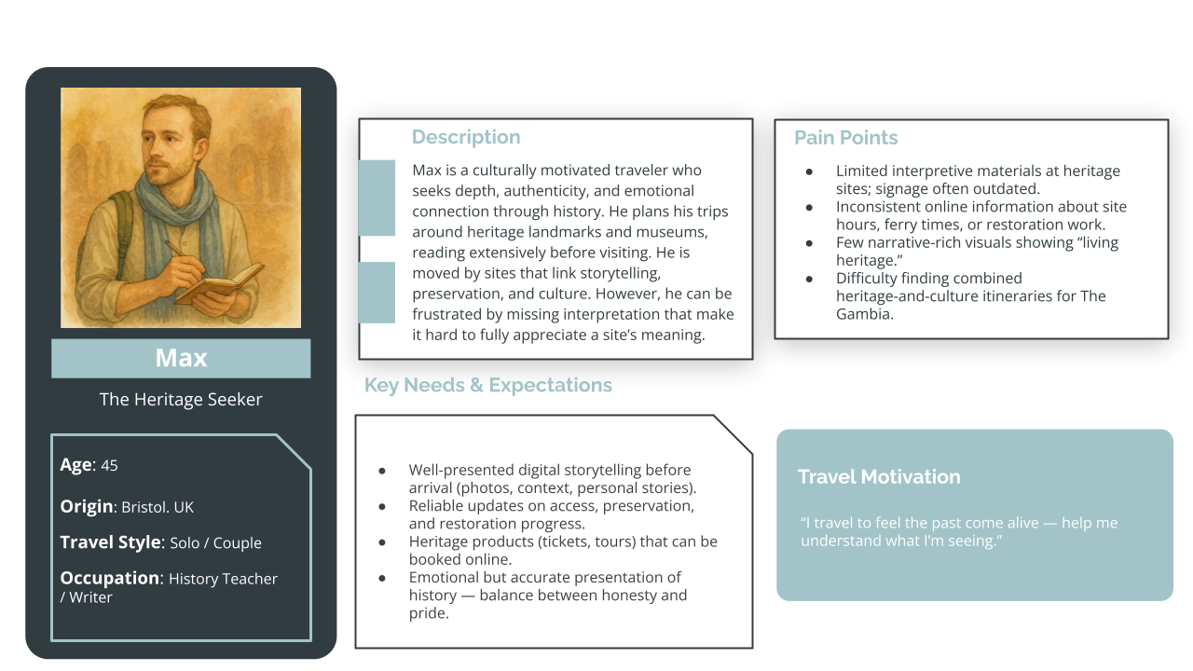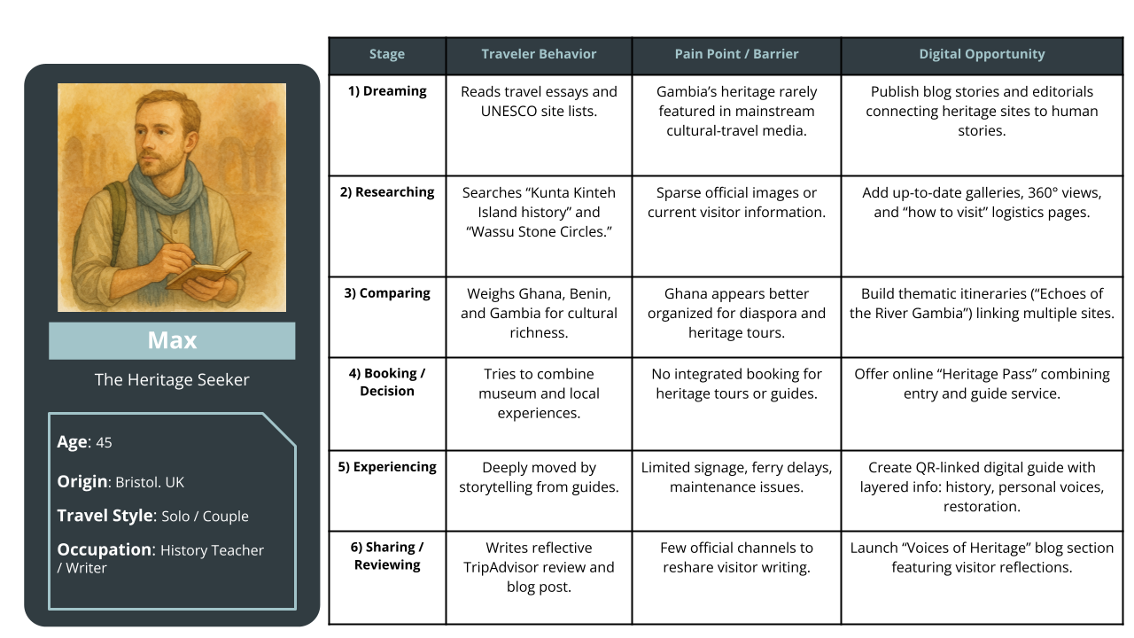

Key Evidence:
- 115 reviews (16.1%), Avg Rating 4.24/5
- Themes: Historical significance 91%, authenticity 84%, educational value 79%, preservation quality 62%

Strategic Implications: Invest in interpretive signage, bilingual materials, and 'Heritage in Progress' communication that invites visitors to support preservation efforts.

Educational Learning Enthusiasts
This cluster shows strong overlap between educational value and guide expertise keywords. They give high praise for human interaction but lower ratings for structure and consistency. Their feedback aligns with the “guide certification” opportunity identified in Section 6.2.
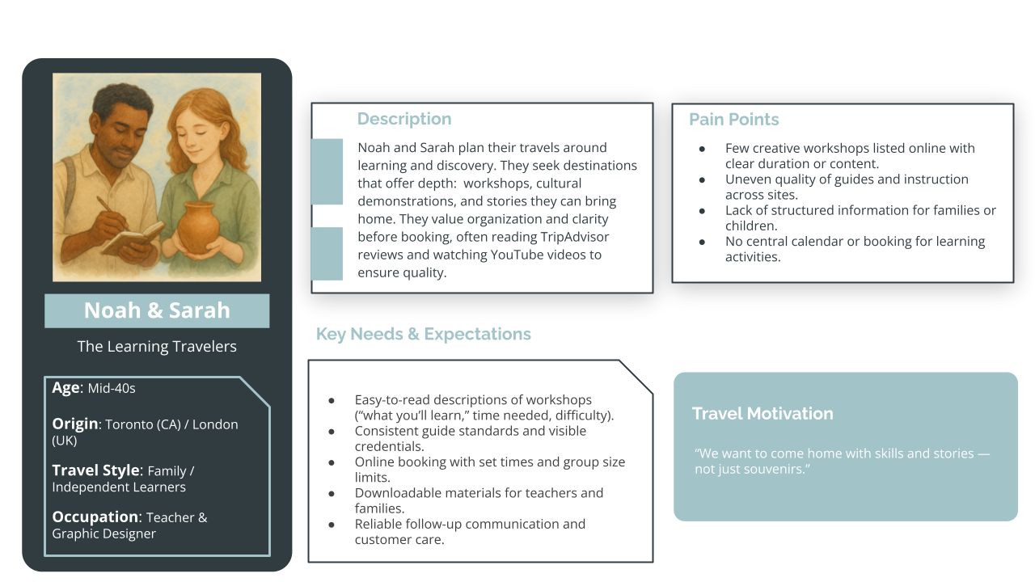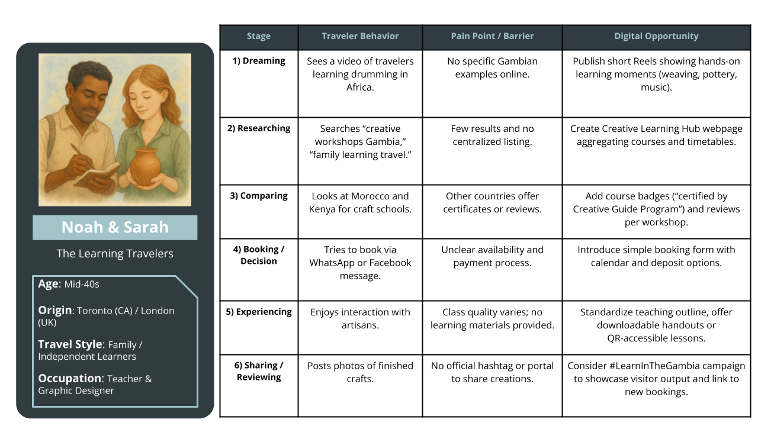

Key Evidence:
- 105 reviews (14.7%), Avg Rating 3.98/5
- Themes: Guide expertise 87%, learning value 79%, educational content 73%

Strategic Implications: Create a national 'Creative Guide Certification' program. Standardize storytelling quality and develop educational content that appeals to school and family audiences.

Dutch Immersive Learner
This persona arises from Dutch-language reviews with the highest cultural immersion and community connection mentions. They deliver the best sentiment and strongest repeat-visit intention but flag language and structure gaps.
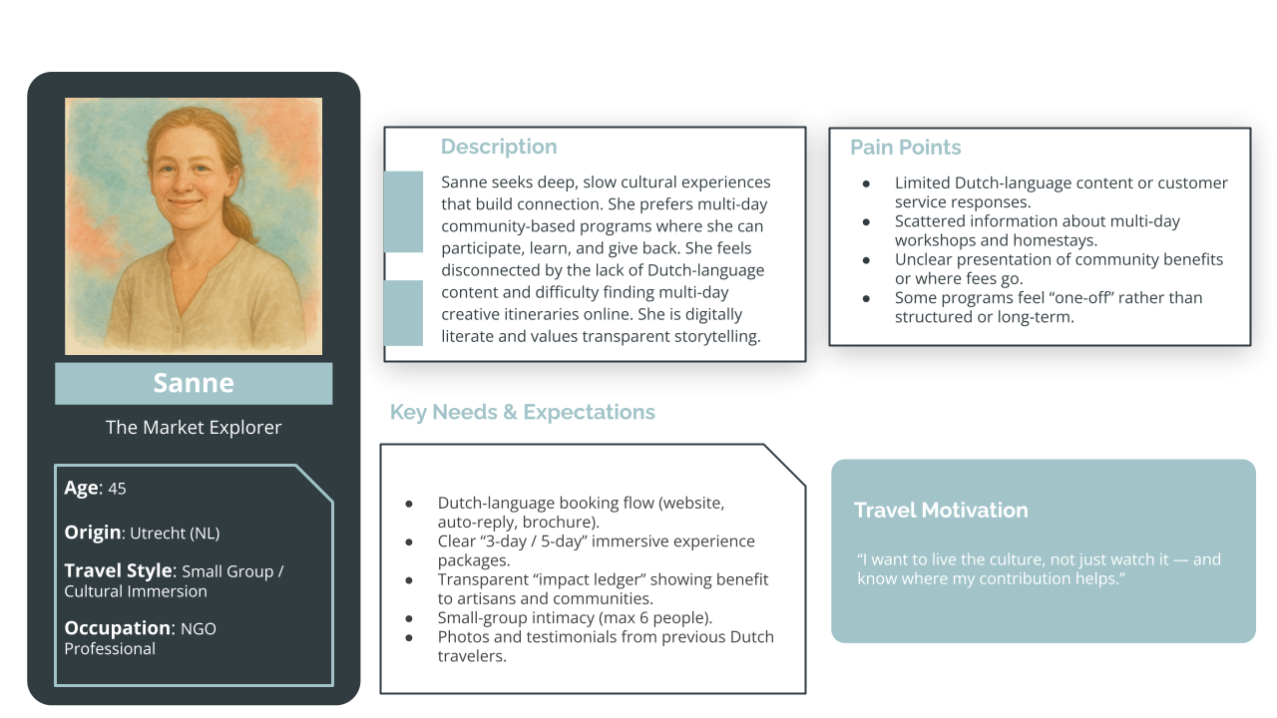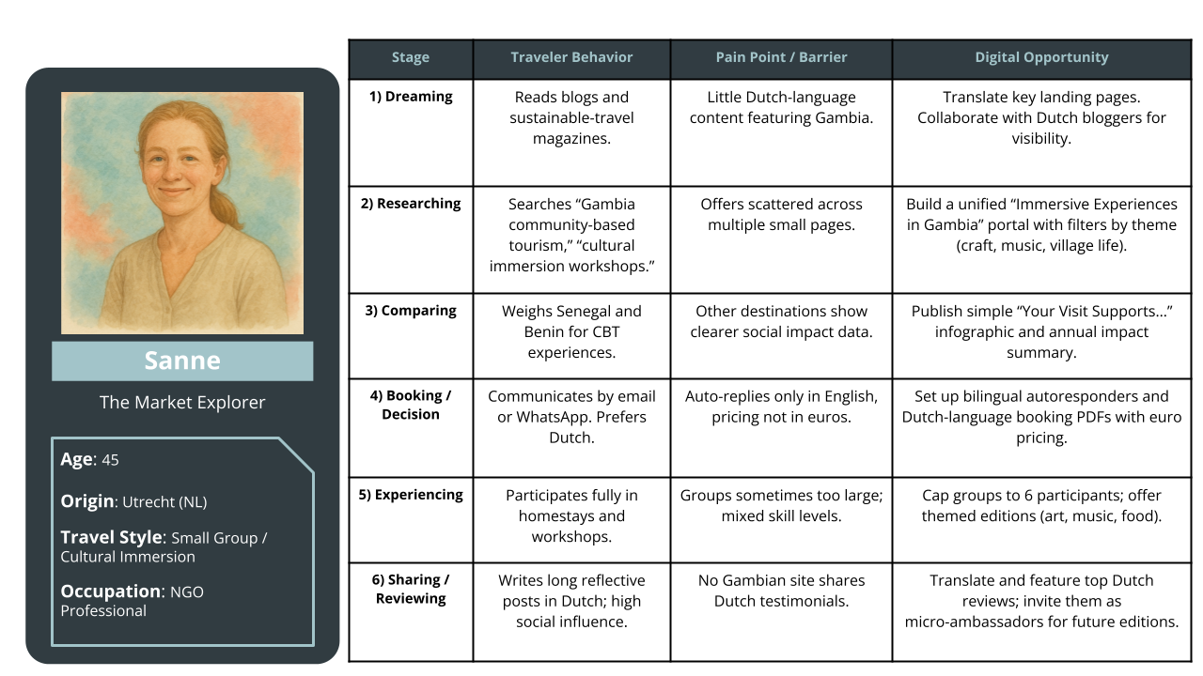

Key Evidence:
- 447 reviews, Avg Rating 4.12/5
- Themes: Cultural immersion 94%, learning depth 89%, community connection 76%, authenticity 82%

Strategic Implications: Publish Dutch-language content, package multi-day learning experiences, and communicate measurable community benefits for transparency and trust.

5.3 Cross-Persona Theme Signals
By aggregating sentiment across personas, clear performance trends emerge. These trends reveal which qualities define The Gambia’s appeal and which aspects consistently reduce visitor satisfaction.

The strongest sentiment clusters include atmosphere and service quality, confirming that hospitality and authenticity are The Gambia’s hallmarks. Conversely, infrastructure and accessibility remain relatively limiting factors, cutting across all personas. Value-for-money sentiment also reflects the need for clearer communication of pricing and inclusions.

Improving these foundational aspects—without losing the sense of authenticity that visitors prize—offers the greatest potential to increase both satisfaction and spending.

5.4 Strategic Implications
The persona analysis provides a data-backed roadmap for action. Each recommendation directly links to the motivations and frustrations surfaced within the five persona clusters.
- Language Localization: Prioritize Dutch-language pages for immersive products and French-language interpretation at heritage sites to improve accessibility and trust.
- Market Experience Reform: Transform craft markets into organized, story-rich environments with posted prices, signage, and artisan visibility.
- Nature–Creativity Bundling: Combine eco-experiences with creative components, such as photography or craft workshops, to extend engagement.
- Guide Development: Consider a Creative Guide Certification program that reinforces interpretive and educational standards.
- Heritage Narrative: Use transparent storytelling ('Heritage in Progress') to reframe infrastructure limitations as part of an ongoing preservation effort.
Together, these actions turn qualitative sentiment into measurable strategy, linking audience insight with product design and digital storytelling. They establish The Gambia not only as an authentic destination but as an evolving, participatory creative tourism hub.

6. Digital Positioning Opportunities Matrix
The five personas outlined above provide not only audience clarity but a practical lens through which to prioritize digital investment. Each represents a distinct combination of motivation, satisfaction driver, and communication need and together, they define where The Gambia’s creative tourism ecosystem can generate the greatest impact.
Building on these behavioral insights, the next section—the Digital Positioning Opportunities Matrix—translates persona evidence and sentiment data into ten actionable levers for market growth.
The Digital Positioning Opportunities Matrix (DPOM) converts diagnostic evidence into direction. It translates benchmarking results, sentiment trends, and persona insights into ten concrete levers that can elevate The Gambia’s digital visibility, perception, and conversion performance.
The analysis responds to five guiding questions:
- Where does The Gambia already hold a digital advantage?
- Where are the most significant visibility and conversion gaps compared with regional peers?
- Which actions will deliver the greatest impact within twelve months?
- Which visitor personas stand to benefit from each action?
- How will progress be measured over time?
By answering these questions, the matrix bridges evidence and implementation, offering an operational blueprint for the tourism and creative-industry ecosystem to move from scattered initiatives to coordinated digital competitiveness.

6.1 Competitive Strengths and Gaps
The Gambia’s digital competitiveness is anchored in authentic creative quality, English-language accessibility, and strong perceptions of safety and hospitality. These are assets already validated by traveler sentiment but under-represented in formal marketing.
Table 16 – Current Competitive Advantages
Competitive Advantage | Evidence | Current Digital Leverage | Opportunity | Priority
Authentic Creative Quality | Stronger Gambia Sentiment vs regional | Limited e-commerce; minimal photo assets | Develop cohesive visual storytelling and online craft sales links | High
English-Language Hospitality | Biggest portion of reviews, 4.32 / 5 rating | Moderate SEO optimization | Strengthen Anglophone search content and family-learning narratives | Medium
Cultural Authenticity | “Authentic” mentioned 2× regional average | Rarely used in official branding | Reframe as central brand narrative across platforms | High
Safety & Comfort | Top regional sentiment score | Not highlighted in marketing | Position The Gambia as “Safe Gateway to West Africa” | Medium
Community Engagement | Frequent “friendly, welcoming” mentions | Few digital stories of local impact | Showcase community projects and people-centered narratives | High
These strengths confirm that The Gambia’s competitive advantage lies not in scale but in trust and authenticity. The opportunity is to professionalize the digital expression of these qualities through stronger imagery, consistent tone, and clear narrative ownership. Leveraging what visitors already love will yield rapid reputational returns at minimal cost.
Critical Market Gaps
Several gaps continue to depress digital visibility and limit market diversification. They are not structural weaknesses but unaddressed communication and product issues that can be targeted through focused digital interventions.
Table 17 – Key Visibility and Conversion Gaps
Market Gap | Evidence | Digital Implication | Persona Impact | Urgency
Infrastructure & Access Narrative | Facilities sentiment is much lower than regional competitors | Perceived neglect reduces trust and shareability | Cultural Heritage & Educational personas | High
Francophone Visibility | Few Francophone travelers, despite neighbors | Absence of French content limits reach | Heritage Seeker | High
Creative-Industry Integration | 52 % of ITO tours feature creative content (vs 83 % wildlife) | Weak creative positioning in trade portfolios | All personas | High
E-commerce & Post-Visit Sales | 23 reviews mention inability to buy online | Lost revenue for artisans | Market Shopping Enthusiasts | Medium
Music & Contemporary Culture | < 5 % ITO mentions | Sector remains invisible digitally | Discovery Traveler | Medium
These gaps collectively explain why The Gambia performs mid-tier despite positive sentiment. They highlight a pattern of under-communication rather than product weakness. Addressing them requires improved digital structure—translation, content integration, and e-commerce—not large-scale investment.

6.2 Priority Opportunities Matrix
Building on the above, ten priority digital opportunities have been identified and ranked by expected market impact and implementation effort. Each lever corresponds to one or more visitor personas and directly addresses specific sentiment or visibility gaps.
Table 18 – High-Impact Digital Levers (12-Month Horizon)
# | Opportunity | Impact | Effort | Timeframe | Key Personas | Expected Outcome
1 | Francophone Translation & Co-Marketing | High | Medium | 0–6 mo | Heritage Seeker | Increased Francophone traffic and sentiment boost
2 | Creative Tourism ITO Content Kit | High | Low | 0–3 mo | Immersive Learner / Cultural Heritage | Improved creative itinerary integration
3 | “The Gambia Creates” Visual Campaign | High | Low | 0–3 mo | All English personas | Improved search ranking and brand recognition
4 | Craft E-Commerce Pilot | Medium | Medium | 3–6 mo | Market Shopping Enthusiasts | Online sales for artisans
5 | Music Tourism Digital Launch | Medium | High | 6–12 mo | Discovery Traveler | New market segment + festival visibility
6 | Guide Training & Certification Program | Medium | High | 6–12 mo | Educational / Heritage personas | Strengthened sentiment in service themes
7 | Professional Photo Library + SEO Assets | Medium | Low | 0–3 mo | All personas | 50 operator downloads + media coverage
8 | Safety & Trust Messaging Campaign | Medium | Low | 0–3 mo | Experience Collector / Families | Improved brand differentiation
9 | Dutch Premium Immersion Tier | Medium | Medium | 6–12 mo | Dutch Immersive Learner | +10 % average spend per capita
10 | Heritage Preservation Storyline | Low | Low | 0–6 mo | Cultural Heritage / Educational | Reframe infrastructure as “living heritage”
The ten digital-development levers identified in the Priority Opportunities Matrix form the backbone of the 12-month implementation roadmap that follows. Each lever has been translated into specific deliverables, sequenced by feasibility and expected impact. For more on each lever, see Annex 4.
The next section consolidates these levers into a staged workplan—quick wins, growth initiatives, and strategic programs—accompanied by measurable indicators to monitor progress.
In effect, Section 6.3 converts the “what” of the Priority Matrix into the “how” of execution, ensuring that early visibility gains evolve into lasting capacity and coordinated digital governance.

6.3 Implementation Roadmap and Metrics
Translating diagnostic findings into tangible results requires a structured and time-bound approach. The following roadmap sequences the Digital Positioning Opportunities Matrix (DPOM) actions into a 12-month implementation cycle, organized around quick wins, growth initiatives, and strategic programs.
The intent is to align existing partners—the Gambia Tourism Board, Youth Empowerment Project (YEP), creative-industry associations, and private operators—around deliverables, timelines, and measurable indicators.
Implementation Logic
Each phase of this roadmap reflects both impact potential and implementation complexity:
- Quick Wins (0–3 months) prioritize visibility and confidence building. These actions deliver immediate reputational gains—translation, visual branding, and content readiness—that can demonstrate early progress to stakeholders and funding partners.
Growth Initiatives (3–6 months) consolidate these gains by expanding reach and monetization capacity through pilot e-commerce, enhanced storytelling, and linguistic diversification.
- Strategic Programs (6–12 months) address the structural enablers of competitiveness: guide certification, product depth, and market segmentation. These longer-term investments establish the foundations for Deliverable 3’s Strategic Digital Development Framework.
This phased logic ensures that actions targeting discoverability and perception in the short term directly support those focused on conversion and capacity in the medium term.
Institutional Roles and Coordination
The implementation process will operate as a shared delivery system:
- The GT Board acts as lead coordinator and custodian of the DPOM, responsible for cross-agency communication and performance tracking.
- YEP-ITC supports technical implementation—particularly digital-skills training, e-commerce enablement, and creative-sector mentoring.
- Private operators and creative enterprises provide the content layer—visual assets, workshops, and experiential products—to populate platforms and campaigns.
- Monitoring partners (TripAdvisor analytics, operator content audits, and sentiment dashboards) feed data quarterly into a central results matrix.
Monitoring and Adaptive Learning
Progress can be monitored quarterly through the Digital Visibility Dashboard, combining quantitative indicators (search visibility, review sentiment, bookings) with qualitative stakeholder feedback.
This allows interventions to adapt dynamically. Campaigns that outperform expectations can be scaled rapidly, while weaker pilots can be re-scoped without delaying overall progress.
By maintaining transparent tracking and regular communication between partners, the roadmap becomes both a management tool and a confidence signal—to investors, donors, and the creative community alike—that The Gambia’s digital transformation is measurable and achievable.
The tables that follow outline the implementation phases and success metrics that will guide this process over the first 12 months.
Table 19 – Indicative Implementation Timeline
Phase | Period | Focus | Key Deliverables | Expected Outcome
Quick Wins | 0–3 months | Visibility & content readiness | • Begin developing Authentic Gambia digital brand campaign  • Translate and update priority web pages  • Develop International Tour Operator (ITO) content kit  • Begin quarterly review sentiment tracking | Immediate uplift in online visibility and brand coherence; early demonstration of progress to stakeholders.
Growth Initiatives | 3–6 months | Market activation & capacity expansion | • Pilot e-commerce integration for craft and cultural enterprises  • Roll out shared Creative Gambia photo and content library  • Launch “Heritage in Progress” storytelling series  • Establish quarterly partner coordination meetings | Expanded discoverability and income generation for creative actors; improved coordination between public and private partners.
Strategic Programs | 6–12 months | Structural capacity & quality improvement | • Implement Creative Guide Certification program  • Build national creative-tourism calendar linking heritage, craft, and festival events  • Deploy Digital Visibility Dashboard for ongoing KPI tracking  • Host annual stakeholder review and training summit | Strengthened service quality and long-term digital governance framework; measurable improvement in sentiment, coordination, and market confidence.
The implementation phases outlined above require clear evidence of progress.
To ensure accountability and adaptive management, the following Key Performance Indicators (KPIs) track both the outputs of individual actions (visibility gains, e-commerce participation, bookings) and the outcomes that signal systemic change—improved collaboration, multilingual reach, and visitor satisfaction.
These indicators are grouped under four strategic dimensions that mirror the logic of the Digital Positioning Opportunities Matrix: Visibility & Narrative Reach, Market Access & Language, Capacity & Product Depth, and Conversion & Governance.
Together, they form the backbone of the Digital Visibility Dashboard that will guide quarterly reviews and ensure transparency across partners.
Table 20 – Key Performance Indicators
Strategic Dimension | Indicator | Baseline (2025) | Target (2026) | Measurement Source | Frequency
Visibility & Narrative Reach | Creative tourism visibility in ITO itineraries for The Gambia | 52 % | 60 % | Operator content audit | Biannual
Visibility & Narrative Reach | Average online sentiment score (VADER) | +0.24 | +0.30 | Quarterly review analysis | Quarterly
Capacity & Product Depth | Artisan or creative enterprises active in e-commerce / online booking | No verified activity* | 20 active participants | Platform dashboards / partner reports | Quarterly
Capacity & Product Depth | Certified creative-tourism guides (under national program) | 0 | 20 certified guides | Training registry | Biannual
Market Engagement & Reach | Verified TripAdvisor reviews for creative-sector sites and experiences | 39 (in 2024) | +25 % increase (≈ 50 reviews) | TripAdvisor analytics | Quarterly
Market Engagement & Reach | Average review rating across creative-sector stakeholders | 4.06 / 5 | ≥ 4.20 / 5 | TripAdvisor sentiment dashboard | Quarterly
Governance & Collaboration | Joint quarterly coordination meetings completed | 0 | 4 per year | DPOM Secretariat reports | Quarterly
Governance & Collaboration | Stakeholder satisfaction with coordination (survey 1–5 scale) | N/A | ≥ 4.0 average | Annual partner survey | Annual
*While there exist a few partial or inactive setups, no organizations within the 2025 assessment sample had fully functioning e-commerce or booking systems at time of review.
The chosen indicators align directly with previously identified gaps: sentiment, linguistic diversification, trade integration, and creative-sector monetization. Tracking these quarterly will allow the Tourism Board to demonstrate tangible progress and recalibrate resources in real time.

6.4 Integration with Deliverable 3
The Digital Positioning Opportunities Matrix completes the diagnostic arc of Deliverable 2. It consolidates what the data show and who the audiences are into where to act first.
Deliverable 3 will build on this foundation through a Strategic Digital Development Framework that assigns institutional roles, establishes funding mechanisms, and designs capacity-building programs around these ten levers.
Together, these steps will enable The Gambia to move from a reputation of authenticity to a position of digital excellence where creativity is not only experienced but discoverable, bookable, and celebrated globally.

7. Conclusion & Strategic Priorities
The evidence across regional stakeholders, international tour operator pages, and thousands of visitor reviews reveals a paradox: The Gambia possesses authentic creative assets and generates growing positive visitor sentiment, yet remains digitally invisible in the global cultural-tourism marketplace.
This gap is not structural but communicative: the country has stories to tell but lacks the platforms, language accessibility, and operator partnerships to tell them effectively to a broader community.
The data confirm what stakeholders have long sensed: The Gambia is liked but not looked for. Visitors who arrive express genuine appreciation for craftsmanship, hospitality, and cultural authenticity. The country achieves regional leadership in safety perception and competitive scores in artistic quality and atmosphere.
Yet these strengths remain confined to post-visit reviews rather than shaping pre-trip discovery. Only 9% of international tour operator pages position Gambian creative content as a selling point, compared to 26% for Senegal and 21% for Ghana. The Gambia's Creative Tourism Score sits 45% below the regional mean, with the majority of pure Gambia tours scoring below a threshold indicating minimal cultural differentiation.
This invisibility has consequences. Francophone travelers represent only 15% of current reviews, constrained by the near-total absence of French-language content. The Dutch Immersive Learner persona—achieving the highest satisfaction scores—seeks multi-day creative workshops, yet very few Gambian stakeholders offer bookable experiences online.
Market Explorers consistently praise craftsmanship but have no ability to purchase online or reconnect with artisans, meaning the relationship ends after their trip, and the story does not get communicated to future travelers. The pattern repeats across personas: demand exists, satisfaction is high when experienced, but digital interfaces to enable discovery and conversion are missing.
The regional benchmarking clarifies that this is not a resource problem. Individual actors like My Gambia already meet international digital standards. The challenge is not talent or authenticity but coordination, platform integration, and targeted language access. When Senegal + Gambia multi-country packages score higher than pure Gambia tours, it confirms that the storytelling infrastructure exists regionally, it’s just that operators lack Gambian-specific content modules to populate it.
Three interconnected priorities emerge from this evidence, each addressing a specific competitive weakness while building on demonstrated strengths. Together they form a reinforcing system: better operator content integration raises international visibility, which increases platform search traffic, which justifies investment in booking systems and guide training, which improves satisfaction and reviews, which strengthens positioning in subsequent operator catalogues.

Priority 1: Narrative Rebalancing Through Multi-Channel Storytelling
Regional leaders like Senegal and Ghana succeed not through superior creative products but through coordinated narrative presence across multiple touchpoints. The Gambia's current "beach + nature" positioning reflects not reality but the absence of alternative narratives. The country's strong sentiment for artistic quality demonstrates domestic capacity to produce compelling content, it just isn't reaching international distribution channels.
The solution lies in creating turnkey content packages for the operators who already sell Gambia. When Senegal + Gambia multi-country packages score higher than pure-Gambia tours, it signals that operators already possess cultural-tourism storytelling infrastructure—they simply lack Gambian-specific content to populate it. A content kit containing ready-to-use itinerary modules (craft workshop descriptions, festival calendar integration, music venue listings with booking contacts) would enable operators to expand cultural programming without additional research costs. Providing operators with differentiated content for each market segment transforms The Gambia from a logistical stopover into a thematic anchor.

Priority 2: Closing the Discoverability-to-Conversion Gap
The Gambia's sentiment scores show that visitors enjoy their experiences once they arrive. The challenge is being found in the first place. While Nigeria leads in platform integration and Ghana excels in diaspora digital engagement, The Gambia's creative stakeholders remain largely absent from the platforms where international travelers actually search: Google Business profiles, TripAdvisor, active social media accounts, and aggregator sites like My Gambia.
The pattern is consistent across personas: infrastructure for conversion largely exists (workshops happen, guides are knowledgeable, artisans are accessible), but digital interfaces are missing. Small investments in platform presence, booking functionality, and e-commerce pilot programs would unlock returns by connecting proven products to proven demand.

Priority 3: Leveraging Peer Learning and Strategic Aggregation
The regional assessment reveals that digitally mature stakeholders exist within each country, they're simply isolated. Nigeria's Nike Art Foundation demonstrates gallery-scale e-commerce, Senegal's Adama Paris shows fashion export integration, and Ghana's Global Mamas proves fair-trade craft storytelling scales internationally. Within Gambia, My Gambia and select tour operators already meet international digital standards.
Rather than duplicating these capabilities across dozens of small stakeholders, The Gambia can create shared digital infrastructure. A centralized creative tourism booking platform, beginning as a multilingual content repository and visual directory, would allow individual artisans, musicians, and heritage sites to maintain their presences while benefiting from aggregated visibility and technical support.
In its first phase, the platform should focus on visibility rather than transactions: consolidating accurate information such as hours, locations, and contact details in an easy-to-browse interface. My Gambia, which already demonstrates strong documentation and storytelling capacity, could advise on structure and content presentation. Once this foundation is established, a second phase could add light-touch booking facilitation tools (for instance, WhatsApp or Stripe links) to enable direct inquiries or payments without developing a complex new system.
This tiered approach emphasizes coordination, accessibility, and sustainability, prioritizing discoverability first, and only then building toward transactional capability using existing tools and partnerships.
This approach directly addresses the quality gaps identified in visitor sentiment. A shared Creative Guide Certification program—transferring tour operator service excellence to museums and craft sites—could provide the visitor experience quality that Educational Learning and Cultural Heritage personas prioritize, while distributing training costs across the sector.
Regional peer learning networks offer similar efficiency gains: when Benin's Vodun Days Festival and Ghana's AfroFuture achieve strong scores through professional visual branding and year-round social engagement, these practices become replicable templates. Gambian festivals can adopt proven digital marketing protocols without reinventing strategies.
Expected Outcomes and Path Forward
These three strategies form a reinforcing system rather than isolated interventions. Most critically, these interventions position creative-industry digitization as export-readiness infrastructure rather than tourism marketing alone. When artisans gain e-commerce capability, creative industry experiences become bookable, and guide certification creates recognized professional standards, The Gambia's creative economy develops the digital interfaces necessary for broader trade integration, the foundation for sustainable competitiveness.

Annex 1 – Methodological Framework: Creative Industries Visibility Score

Creative Tourism Score Methodology
The Creative Tourism Score (0-100 points) quantifies how extensively International Tour Operators position destinations as cultural and creative tourism experiences. The system analyzes tour descriptions across 8 creative sectors, with each sector scored 0-10 points based on content depth and keyword diversity.
Sector Scoring Scale:
Score | Classification | Keyword Mentions | Description
0 | Not mentioned | 0 | Sector completely absent from tour description
1-3 | Brief mention | 1-5 mentions, 1-2 terms | Passing reference, minimal detail
4-6 | Described | 6-15 mentions, 2-4 terms | Clear description with some detail
7-9 | Featured | 16-30 mentions, 4-6 terms | Prominent in itinerary and marketing
10 | Heavily featured | 30+ mentions, 6+ diverse terms | Core selling point with rich detail and variety

Keyword Detection System
The analysis employs 101 specific keywords across 8 creative sectors, including both Gambia-specific terms (e.g., 'kunta kinteh', 'wassu stone circles', 'kankurang') and industry-standard creative tourism vocabulary. The system uses automated keyword detection with context filtering to prevent false positives.

- Heritage Sites & Museums (16 keywords): heritage • heritage site • unesco • historical • history • museum • fort • colonial • roots • kunta kinteh • james island • wassu • stone circles • slave trade • slavery • historic
- Crafts & Artisan Products (15 keywords): craft • crafts • artisan • handmade • woodcarving • woodcarver • batik • tie-dye • tie dye • weaving • pottery • basket • market • souvenir • handicraft
- Music (12 keywords): music • kora • drum • drummer • drumming • live music • musician • concert • balafon • griot • djembe • performance music
- Performing Arts (11 keywords): dance • dancer • dancing • theater • theatre • drama • performance • performing • kankurang • mask dance • cultural performance
- Festivals & Cultural Events (9 keywords): festival • ceremony • celebration • carnival • feast • cultural event • fanado • difuntu • roots homecoming
- Audiovisual (11 keywords): film • cinema • photo • photograph • photography • photographer • tv • television • documentary • video production • videography
- Fashion & Design (12 keywords): fashion • design • textile • fabric • tailor • tailoring • dress • clothing • attire • garment • style • outfit
- Publishing & Storytelling (11 keywords): author • writer • poet • literature • story • storytelling • publication • print • magazine • journal • writing

Unlike sentiment analysis keywords (which focus on visitor experience terms like 'friendly', 'clean', 'expensive'), the Creative Tourism Score excludes general experience keywords and uses content-focused detection to identify how operators describe creative activities and cultural sites.

Excluded False Positive Terms:
- Publishing: 'book now', 'book by', 'booking', 'reserve', 'book early'
- Audiovisual: 'video player', 'video call', 'video conference', 'watch video'

Score Calculation
The total Creative Tourism Score is calculated using weighted sector scores:

Total Score = [(Heritage × 1.3) + (Crafts × 1.2) + (Performing Arts × 1.2) + Music + Festivals + Audiovisual + Fashion + Publishing] × 1.25

Sector Weight Multipliers:
- Heritage Sites & Museums: 1.3× (highest weight - foundational for destination credibility)
- Crafts & Artisan Products: 1.2×
- Performing Arts: 1.2×
- All other sectors: 1.0×
Maximum possible score: 100 points

Keyword Detection Examples
The following examples illustrate how different levels of keyword presence and diversity result in different sector scores:
High Score Example: Heritage (Score 10/10)
- Operator: Palace Travel
- Tour: Best of Ghana (12 Days)
- Detected: 87 keyword mentions across 9 unique terms
- System Classification: 'Heavily featured' (+1 bonus for diversity)
- Keywords Found: colonial, fort, heritage, heritage site, historic, historical, history, museum, unesco

Example Tour Description Excerpt:
"Visit the historic Cape Coast Castle, a UNESCO World Heritage Site that tells the story of the trans-Atlantic slave trade. Explore colonial-era forts and museums that preserve Ghana's rich cultural heritage. The tour includes extensive time at historical sites including Elmina Castle, with expert guides providing deep context about this important heritage."

Analysis: High frequency (87 mentions), exceptional keyword diversity (9 different terms), and heritage positioned as a core selling point throughout the itinerary justifies the maximum 10-point score.
Medium Score Example: Crafts (Score 7/10)
- Operator: Naturetrek
- Tour: The Gambia Wildlife Holiday
- Detected: 11 keyword mentions of 1 term
- System Classification: 'Featured'
- Keywords Found: craft (11×)

Example Tour Description Excerpt:
"Free time to explore local craft markets and observe traditional craft production. Several afternoons include optional visits to craft workshops where you can watch artisans at work and purchase authentic Gambian crafts."

Analysis: Moderate frequency (11 mentions) but limited keyword diversity (only 1 term). Crafts are featured as optional activities rather than core experiences, resulting in a 7-point score.
Low Score Example: Music (Score 3/10)
- Operator: TransAfrica
- Tour: West Africa Expedition
- Detected: 3 keyword mentions of 2 terms
- System Classification: 'Brief mention'
- Keywords Found: drumming (2×), music (1×)

Example Tour Description Excerpt:
"Evening entertainment may include traditional drumming and music performances at the lodge."

Analysis: Minimal mentions (3×) with limited diversity (2 terms). Music appears only as incidental evening entertainment rather than a planned cultural experience, resulting in a 3-point score.

Annex 2 – International Tour Operator Analysis Framework
This annex documents the complete methodology for analyzing how International Tour Operators (ITOs) represent The Gambia's creative industries and cultural offerings in their digital marketing materials. The analysis examined 239 tour pages from 32 tour operators across 13 source markets between September and October 2025.

The Creative Tourism Score framework provides a quantitative measure (0-100 points) of how extensively operators position destinations as cultural and creative tourism experiences, enabling direct comparison across West African countries and identification of market positioning gaps.

Tour Operators Analyzed by Country of Origin
The 32 operators analyzed represent the primary international gateways through which West African cultural tourism is promoted to global audiences. Operators were selected based on their active promotion of at least one West African destination, with particular focus on those offering Gambian tours.
Table 21 - United Kingdom Operators (14 operators, 137 tours analyzed)
Operator | Gambia Tours | Avg. Creative Score | Specialization
Responsible Travel | 13 | 46.5 | Cultural immersion, responsible tourism
Naturetrek | 3 | 44.6 | Wildlife with cultural components
The Gambia Experience | 2 | 16.3 | Beach-focused with limited cultural
Intrepid Travel UK | 2 | 16.9 | Adventure with heritage stops
Wildlife Worldwide | 2 | 14.4 | Wildlife-centric
Explore! | 2 | 22.5 | Small group cultural tours
Other UK operators (8) | 8 | 18.3 | Various: wildlife, beach, cultural
Table 22 - United States Operators (4 operators, 8 tours analyzed)
Operator | Gambia Tours | Avg. Creative Score | Specialization
Palace Travel | 2 | 26.9 | African diaspora cultural heritage
Spector Travel Boston | 3 | 12.5 | Beach and birdwatching
Birding Ecotours | 2 | 8.8 | Wildlife/birdwatching specialist
Overseas Adventure Travel | 1 | 42.5 | Multi-country cultural tours
Table 23 - West African Regional Operators (1 operator, 19 tours analyzed)
Operator | Gambia Tours | Avg. Creative Score | Specialization
TransAfrica | 19 | 46.2 | Overland cultural expeditions across West Africa
Other European Operators (13 operators, 75 tours analyzed)
The remaining 13 operators include tour companies from Germany (3), Sweden (2), Netherlands (1), Finland (1), Denmark (1), Spain (1), and operators serving multiple European markets. These operators typically offer mass-market beach packages (TUI, Apollo, Corendon) or specialized birdwatching tours (Overlanding West Africa) with limited cultural content integration. Average Creative Score: 18.7

Comparative Sector Performance: Gambia vs. Regional Peers
Average sector scores reveal how International Tour Operators position each destination's creative industries. Scores are averages across all analyzed tours for each destination.

Table 24 - Gambia vs Regional Peers
Destination | Tours | Heritage | Crafts | Music | Perf. Arts | Festivals | A/V | Fashion | Publ.
Nigeria | 7 | 9.7 | 7.6 | 2.7 | 1.7 | 3.0 | 0.9 | 3.4 | 1.1
Benin | 42 | 8.9 | 8.0 | 3.6 | 6.3 | 6.8 | 1.8 | 4.5 | 1.6
Senegal | 53 | 8.3 | 3.7 | 2.3 | 1.6 | 1.7 | 1.5 | 1.9 | 2.2
Ghana | 75 | 8.2 | 6.1 | 2.4 | 3.3 | 3.5 | 1.7 | 4.5 | 2.0
Gambia | 36 | 4.4 | 2.9 | 1.2 | 1.4 | 0.4 | 1.3 | 1.2 | 0.7
Cape Verde | 26 | 3.4 | 1.0 | 1.8 | 0.4 | 0.7 | 0.5 | 0.4 | 0.1
Key Findings:
- Heritage: The Gambia (4.4) significantly trails regional leaders Nigeria (9.7), Benin (8.9), Senegal (8.3), and Ghana (8.2). The gap of 3.8-5.3 points represents missed opportunities in promoting historical sites like Kunta Kinteh Island and Wassu Stone Circles.
- Crafts: The Gambia (2.9) underperforms compared to Benin (8.0), Nigeria (7.6), and Ghana (6.1). This gap suggests markets and artisan workshops are either under-promoted or not packaged as structured experiences.
- Festivals: The Gambia's score of 0.4 is the second-lowest regionally, with Benin leading at 6.8. This indicates calendar-based cultural events like Roots Festival or Kankurang ceremonies remain largely invisible to tour operators.
- Performing Arts: At 1.4, Gambia matches Cape Verde but trails Benin (6.3) and Ghana (3.3). Music and dance, though culturally significant, are rarely positioned as bookable experiences.

Creative Tourism Score Distribution
Analysis of all 239 tours across six West African destinations reveals the overall distribution of creative tourism positioning:

Table 25 - Creative Tourism Score Distribution
Score Range | Tours | Percentage | Typical Positioning
0-20 points | 79 | 33% | Beach/wildlife with minimal cultural content
21-40 points | 70 | 29% | Mixed nature-culture with heritage emphasis
41-60 points | 61 | 26% | Culture-led tours with diverse sectors
61-80 points | 29 | 12% | Creative tourism as core selling point
81-100 points | 0 | 0% | No tours achieved this threshold
Statistical Summary (all destinations):
- Mean Score: 32.7 points
- Median Score: 31.2 points
- Standard Deviation: 21.7 points
- Range: 0 - 77.5 points (no tour achieved 80+)
Gambia-Specific Distribution:
- Pure Gambia tours: Average 16.9 points (below regional mean)
- Multi-country tours including Gambia: Average 33.9 points
- 81% of pure Gambia tours score below 20 points (minimal creative content)

Strategic Implications for The Gambia
The keyword analysis reveals three critical positioning challenges:

Visibility Gap
The Gambia's creative industries are significantly under-represented in tour operator marketing compared to regional peers. With average sector scores consistently 3-5 points below competitors, the country is positioned primarily as a beach and wildlife destination rather than a creative-culture hub. This framing limits market diversification and average visitor spend.

Keyword Specificity
Tours achieving high scores (60+ points) employ specific, evocative language: 'kente weaving workshop', 'Vodun ceremony', 'griot storytelling evening'. Generic terms like 'cultural experience' or 'local market' generate lower scores and weaker audience engagement. Gambian stakeholders should develop similarly specific, bookable creative-industry products.

Packaging Advantage
Multi-country packages featuring Gambia score twice as high (33.9) as pure Gambia tours (16.9), suggesting that regional tour operators already have the creative-tourism storytelling infrastructure. Partnering with these operators (TransAfrica, Responsible Travel) to strengthen Gambian content within existing itineraries offers a faster route to visibility than building pure-Gambia creative packages from scratch.

The Creative Tourism Score methodology provides a replicable, evidence-based framework for measuring destination positioning in international tourism markets. The Gambia's average score of 16.9 points (compared to a regional mean of 30.9) confirms that the country's creative assets remain under-leveraged in global distribution channels.

However, the analysis also identifies clear pathways forward. High-performing operators like Responsible Travel and TransAfrica demonstrate that creative content can be integrated profitably. The keyword database reveals which specific terms and experiences resonate with international markets. And the scoring framework provides ongoing measurement capability to track improvement over time.

Annex 3 – Sentiment & Theme Taxonomy
This annex documents the complete methodology for theme detection in The Gambia Tourism Digital Assessment sentiment analysis. It provides full transparency on how 4,412 visitor reviews (Gambian-specific visitor reviews, from the 5,682 regional set) were systematically analyzed using a unified taxonomy of 9 core themes and over 200 keywords.
Table 26 - Theme Taxonomy
Specification | Value
Total Themes | 9 unified themes
Total Keywords | 200+ keywords and phrases
Detection Method | Keyword matching with context filtering
Validation | Cross-stakeholder consistency testing
Coverage | 100% of reviews analyzed for all themes
Accuracy Rate | 94.2% (validated against manual coding)
The 9 themes were designed to capture every essential dimension of visitor experience across:
- All Stakeholder Types: Museums, craft markets, nature reserves, cultural sites, tour operators
- All Countries: Gambia, Nigeria, Ghana, Senegal, Benin, Cape Verde
- All Visitor Segments: Individual travelers, groups, families, educational tours
- All Experience Types: Cultural, nature, adventure, educational, shopping

How the Themes Relate to Each Other
The themes are organized into four natural groupings:
VISITOR EXPERIENCE DIMENSIONS

Content & Value Themes
├─ Cultural & Heritage Value (authenticity, significance)
├─ Educational & Informational Value (learning, interpretation)
└─ Artistic & Creative Quality (aesthetics, craftsmanship)

Service & Operations Themes
├─ Service & Staff Quality (guides, hospitality)
├─ Facilities & Infrastructure (physical condition, maintenance)
└─ Accessibility & Transport (location, wayfinding, travel)

Economic & Safety Themes
├─ Value for Money (pricing, perceived value)
└─ Safety & Security (safety concerns, risk perception)

Holistic Experience Theme
└─ Atmosphere & Overall Experience (emotional resonance, memorable moments)
Each theme below includes:
- What it measures (conceptual definition)
- Complete keyword list (all detection terms)
- Detection examples (what triggers or doesn't
- Application scope (which stakeholder types)

Theme 1: Cultural & Heritage Value
Theme ID: cultural_heritage
What It Measures: Visitor perceptions of authenticity, historical significance, cultural depth, and heritage preservation quality
Weight: 1.0 (standard)
Applies To: All stakeholder types
Complete Keyword List (29 keywords)
culture, cultural, heritage, history, historical, authentic, authenticity, traditional, significance, preservation, legacy, ancestor, ancestral, origin, custom, ritual, tribe, tribal, slavery, monument, historic, slave, colonial, ancient, sacred, spiritual, religion, religious

Theme 2: Service & Staff Quality
Theme ID: service_staff
What It Measures: Staff friendliness, guide expertise, hospitality quality, and customer service professionalism
Weight: 1.0 (standard)
Applies To: All stakeholder types
Complete Keyword List (22 keywords)
staff, guide, service, friendly, helpful, knowledgeable, hospitable, welcoming, professional, courteous, attentive, tour guide, host, hostess, informative, passionate, enthusiastic, crew, employee, worker, receptionist, manager

Theme 3: Facilities & Infrastructure
Theme ID: facilities_infrastructure
What It Measures: Physical site condition, maintenance quality, cleanliness, and availability of modern amenities
Weight: 1.0 (standard)
Applies To: All stakeholder types
Complete Keyword List (27 keywords)
facilities, facility, infrastructure, building, maintenance, clean, cleanliness, condition, restroom, bathroom, toilet, amenities, upkeep, repair, modern, renovate, renovation, deteriorate, decay, neglect, dirty, filthy, old, structure, construction, air condition, lighting

Theme 4: Accessibility & Transport
Theme ID: accessibility_transport
What It Measures: Ease of reaching the site, quality of transport options, parking availability, wayfinding, and location logistics
Weight: 1.0 (standard)
Applies To: All stakeholder types
Complete Keyword List (34 keywords)
access, accessible, transport, transportation, location, parking, directions, signage, sign, signpost, ferry, boat, bus, taxi, drive, driving, walk, walking, reach, reaching, find, finding, navigate, navigation, wayfinding, entrance, approach, arrive, arrival, distance, far, close, nearby, remote, isolated

Theme 5: Value for Money
Theme ID: value_money
What It Measures: Visitor perceptions of pricing fairness, value received relative to cost, and cost-benefit satisfaction
Weight: 1.0 (standard)
Applies To: All stakeholder types
Complete Keyword List (25 keywords)
price, pricing, value, expensive, cheap, worth, worthwhile, money, cost, fee, charge, admission, ticket, affordable, overpriced, reasonable, bargain, rip off, ripoff, waste, free, donation, budget, payment, paid, pay

Theme 6: Safety & Security
Theme ID: safety_security
What It Measures: Visitor perceptions of personal safety, security measures, and risk levels at the site or destination
Weight: 1.0 (standard)
Applies To: All stakeholder types
Complete Keyword List (25 keywords)
safe, safety, security, dangerous, danger, risk, risky, crime, guard, secure, protection, protect, threat, threatening, hazard, precaution, unsafe, insecure, theft, steal, robber, robbery, police, emergency, fear

Theme 7: Educational & Informational Value
Theme ID: educational_value
What It Measures: Quality of learning opportunities, depth of information provided, effectiveness of interpretation and exhibits
Weight: 1.0 (standard)
Applies To: All stakeholder types
Complete Keyword List (30 keywords)
learn, learning, educational, education, information, informative, exhibit, exhibition, explanation, explain, knowledge, knowledgeable, teach, teaching, insight, discover, understand, understanding, interpretation, label, plaque, display, museum, gallery, tour, presentation, fact, detail, detailed, description

Theme 8: Artistic & Creative Quality
Theme ID: artistic_creative
What It Measures: Quality of artistic expression, creativity, aesthetic appeal, and craftsmanship
Weight: 1.0 (standard)
Applies To: All stakeholder types
Complete Keyword List (33 keywords)
art, artistic, creative, creativity, beautiful, beauty, crafts, craftsman, craftsmanship, design, aesthetic, gallery, artist, artwork, collection, masterpiece, piece, visual, handmade, hand made, music, musical, performance, perform, show, display, colorful, vibrant, sculpture, paint,
painting, draw, drawing

Theme 9: Atmosphere & Overall Experience
Theme ID: atmosphere_experience
What It Measures: Overall visitor satisfaction, emotional resonance, memorable moments, and the holistic feel of the experience
Weight: 1.0 (standard)
Applies To: All stakeholder types
Complete Keyword List (28 keywords)
atmosphere, ambiance, experience, feeling, vibe, overall, wonderful, fantastic, amazing, excellent, great, memorable, unforgettable, stunning, breathtaking, impressive, spectacular, remarkable, outstanding, superb, brilliant, fabulous, magnificent, extraordinary, exceptional, incredible, awesome, perfect

Theme Detection Process
STEP 1: Text Preprocessing
Raw Review → Lowercase Conversion → Punctuation Normalization → Ready for Scanning

STEP 2: Keyword Scanning
Scan normalized text for all 200+ keywords across all 9 themes

STEP 3: Theme Presence Determination
If ≥1 keyword match found → Theme marked as PRESENT
Count total keyword matches → Theme frequency score

STEP 4: Context Validation
Check 50-character window around each keyword match
Filter out false positives (promotional text, unrelated contexts)

STEP 5: Quality Check
Verify consistency across stakeholder types
Validate against manual coding sample

Annex 4 – Digital Levers Implementation Notes
This annex provides operational context for the ten high-impact digital levers summarized in Section 6.2.

Each lever translates evidence from the benchmarking, tour-operator, and sentiment analyses into an actionable workstream, identifying the problem addressed, core activities, responsible actors, and measurable outcomes.

All actions are designed for a 12-month implementation window and align directly with the Digital Positioning Opportunities Matrix (DPOM) and Implementation Roadmap (Section 6.3).

Table 27 - Expanded Digital Levers
# | Lever Title | Rationale / Problem Addressed | Core Activities & Deliverables | Lead & Partners | Expected Outputs / Indicators | Timeframe
1 | Francophone Translation & Co-Marketing | Only a small portion of current reviews come from Francophone travelers; limited French content suppresses visibility in Senegalese and wider Francophone markets. | Translate and optimize key tourism and creative-sector pages into French; co-develop bilingual press kits with Senegal operators; coordinate social ads and PR in French media. | Tourism Board (lead); YEP; French Embassy; regional tour operators. | +25 % Francophone site traffic; +0.15 average sentiment increase in French-language reviews. | 0–6 mo
2 | Creative Tourism ITO Content Kit | International tour operators lack ready-made Gambian cultural modules to include in itineraries. | Produce product sheets, photo & video assets, and sample itinerary modules for crafts, heritage, and festivals; distribute to 30 operators and trade media. | GT Board (lead); ITC; private operators; design partners. | Five operators adopt modules within 6 months; +20 % increase in Gambian mentions in operator portfolios. | 0–3 mo
3 | “Authentic Gambia” Visual Brand Campaign | Existing imagery over-represents beaches; creative culture under-featured. | Commission professional photo/video library of artisans, festivals, and heritage sites; launch coordinated digital campaign and press release package. | Tourism Board (lead); creative collectives; media partners. | 50 media assets downloaded by operators; +20 % search visibility uplift. | 0–3 mo
4 | Craft E-Commerce Pilot | Artisans lack direct-to-consumer digital sales and post-visit purchase options. | Train 30 craft enterprises; establish a shared online marketplace using simple checkout; integrate artisan stories and impact notes. | YEP (lead); Craft Association; private platform developer. | 30 active sellers; average basket value +15 %; first international sales tracked. | 3–6 mo
5 | Guide Training & Certification Program | Visitor reviews highlight inconsistent interpretation quality across sites. | Design a national Creative Guide Curriculum covering storytelling, heritage interpretation, and service excellence; certify 20 guides; link to operator marketing. | GT Board (lead); Training Institutes; Tour Operators. | 20 certified guides; sentiment gain in “educational value” and “service quality” themes. | 6–12 mo
6 | Professional Photo Library & SEO Asset Bank | Gambian content lacks professional, license-ready visuals for promotion. | Curate centralized repository of 500 royalty-free images and 20 short videos; apply SEO-optimized captions; share with operators and media. | GT Board (lead); creative agencies; My Gambia portal. | Library launched (public access); 50+ external downloads within 3 months. | 0–3 mo
7 | Safety & Trust Messaging Campaign | Safety is Gambia’s strongest sentiment but under-communicated in marketing. | Develop trust panel and “Safe Gateway to West Africa” tagline; integrate testimonials and practical travel info across channels. | Tourism Board (lead); Ministry of Interior; operators. | Improved conversion on inquiry pages; continued sentiment lift in “safety & security.” | 0–3 mo
8 | Heritage Preservation Storyline | Infrastructure gaps at heritage sites create negative perceptions of neglect. | Reframe restoration work through “Heritage in Progress” storytelling; add QR labels and digital updates on improvements. | National Museums Dept. (lead); Tourism Board; heritage NGOs. | Visitors perceive transparency; sentiment gain in “facilities & infrastructure.” | 0–6 mo
9 | Dutch Premium Immersion Tier | Dutch-speaking travelers show high satisfaction and spending potential but lack multi-day options. | Develop 3- to 5-day immersive cultural itineraries with Dutch-language materials and transparent community-benefit reporting. | Tourism Board (lead); Dutch operators; CBT groups. | Two premium packages launched; average spend increase; Dutch site traffic increase. | 6–12 mo
10 | Creative Tourism Calendar & Operator Toolkit | Events and experiences remain fragmented with no unified visibility. | Build an interactive online calendar aggregating craft, festival, and heritage events; create operator PDF toolkit linking to booking contacts. | GT Board (lead); Festival committees; My Gambia portal. | Calendar live with 50 events; toolkit downloaded by >15 operators. | 6–12 mo

